Program No..01
Program: To find out the total number of an odd digits and even digits within the given number and print the sum of all odd digits and sum of even digits.

Code:

using System;

namespace Assighment
{
internal class Program
{
static void Main(string[] args)
{
Console.WriteLine("Name : Shubham Ydava");
Console.WriteLine("Class: MCA 3rdSem");
Console.WriteLine("Session:-2024-25");

String input;
Console.Write("Enter the Number :");
input = Console.ReadLine();
if(input == null)
{
Console.WriteLine("Please enter number.");
}
else
{
int odd = 0, Sumodd = 0;
int even = 0, Sumeven = 0;
foreach(char c in input)
{
int digit = c - '0';
if (digit % 2 == 0)
{
even++;
Sumeven += digit;
}
else
{
odd++;
Sumodd += digit;
}

}
Console.WriteLine("Number of even digit :" + even);
Console.WriteLine("Sum of even digit :" + Sumeven);
Console.WriteLine("Number of odd digit :" + odd);
Console.WriteLine("Sum of odd digit :" + Sumodd);
}
Console.ReadLine();
}

}

}

Output:
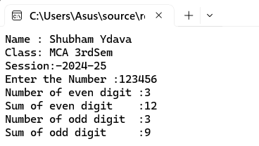

Program No.02
Program: Write a C# program to input a number and check whether the number is Armstrong or not. A number is Armstrong number if sum of each digit raised to (total digit) is number.
Code:
using System;

namespace assighment2
{
internal class Program
{
static void Main(string[] args)
{
Console.WriteLine("Name : Shubham Yadav");
Console.WriteLine("Class : MCA 3rd Sem");
Console.WriteLine("Session: 2024-25");
Console.Write("Enter a number: ");
string input = Console.ReadLine();
if(input == null)
{
Console.WriteLine("Please enter number.");
}

int number = Convert.ToInt32(input);
int originalNumber = number;
int digitCount = input.Length;
int sum = 0;
while (number > 0)
{
int digit = number % 10;
sum += (int)Math.Pow(digit, digitCount);
number /= 10;
}
if (sum == originalNumber)
{
Console.WriteLine($"{originalNumber} is an Armstrong number.");
}
else
{
Console.WriteLine($"{originalNumber} is not an Armstrong number.");
}
Console.ReadLine();
}
}
}

Output:
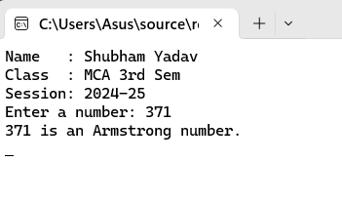
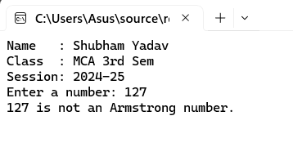

Program No.03
Program:Write a C# program to check whether number is Harshad Number or not.
Code:
using System;
using System.Collections.Generic;
using System.Linq;
using System.Text;
using System.Threading.Tasks;

namespace assighment3
{
internal class Program
{
static void Main(string[] args)
{
Console.WriteLine("Name : Shubham Yadav");
Console.WriteLine("Class : MCA 3rd Sem");
Console.WriteLine("Session: 2024-25");
String input;
Console.Write("Enter a number:");
input = Console.ReadLine();
if (input == null)
{
Console.WriteLine("please enter a number.");
}
else
{
int number = Convert.ToInt32(input);
int sum = 0;
int temp = number;
while (temp > 0)
{
sum += temp % 10;
temp /= 10;
}
if (number % sum == 0)
{
Console.WriteLine($"{number} is Harshad Number.");
}
else
{
Console.WriteLine($"{number} is not Harshad Number.");
}
}
Console.ReadLine();
}
}}
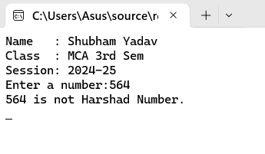
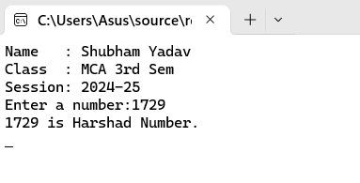
Output:

Program No..04
Program: Write a C# program to find prime number between range of start number and end number.
Code:
using System;

namespace assighment3
{

internal class Program
{

static void Main(string[] args)
{
Console.WriteLine("Name : Shubham Yadav");
Console.WriteLine("Class : MCA 3rd Sem");
Console.WriteLine("Session: 2024-25");
int start, end;
Console.Write("Enter a Start number:");
start = int.Parse(Console.ReadLine());
Console.Write("Enter a end number:");
end = int.Parse(Console.ReadLine());
Console.WriteLine($"Prime number between {start} and {end}");
for (int number = start; number <= end; number++)
{
if (IsPrime(number))
{
Console.Write(number + " ");
}
}
Console.ReadLine();
}
static bool IsPrime(int number)
{
if (number < 2) return false;
for (int i = 2; i <= Math.Sqrt(number); i++)
{
if (number % i == 0) return false;
}
return true;
}
}
}

Output:

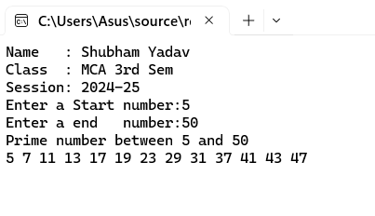

Program No..05
Program: Write a C# program to find out tin prime numbers between 10 to 1000. Twin primes are defined to be two consecutive odd number which are prime.
Code:
using System;

namespace assighment3
{
internal class Program
{
static void Main(string[] args)
{
Console.WriteLine("Name : Shubham Yadav");
Console.WriteLine("Class : MCA 3rd Sem");
Console.WriteLine("Session: 2024-25");

for (int number = 10; number <= 1000; number++)
{
if (IsPrime(number) && IsPrime(number + 2))
{
Console.WriteLine($"({number}, {number + 2})");
}
}
Console.ReadLine();
}

static bool IsPrime(int number)
{

if (number < 2) return false;
for (int i = 2; i <= Math.Sqrt(number); i++)
{
if (number % i == 0) return false;
}
return true;
}
}
}

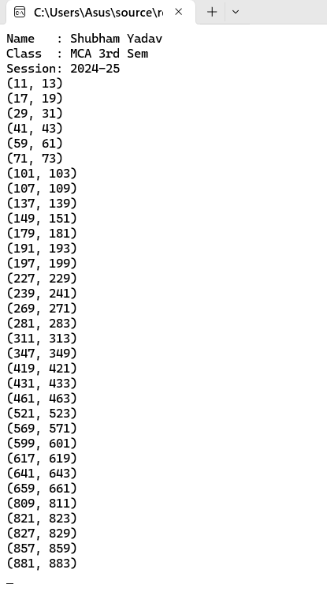
Output:

Program No..06
Program: Enter two positive integers and calculate and print out the sum of the products of each pair of digits occupying the same position in the two numbers.
Code:
using System;
namespace assighment3
{
internal class Program
{
static void Main(string[] args)
{
Console.WriteLine("Name : Shubham Yadav");
Console.WriteLine("Class : MCA 3rd Sem");
Console.WriteLine("Session: 2024-25");
Console.Write("Enter the first number :");
String input1 = Console.ReadLine();
Console.Write("Enter the second number:");
String input2 = Console.ReadLine();
int num1=Convert.ToInt32(input1);
int num2=Convert.ToInt32(input2);
int sumOfProducts = 0;
if(num1 < 0 || num2 < 0)
{
Console.WriteLine("Please enter positive number.");
}
for (int i = 0; i < Math.Max(input1.Length, input2.Length); i++)
{
int digit1 = (i < input1.Length) ? input1[input1.Length - 1 - i] - '0' : 0;
int digit2 = (i < input2.Length) ? input2[input2.Length - 1 - i] - '0' : 0;
sumOfProducts += digit1 * digit2;
}
Console.WriteLine($"The sum of the products of corresponding digits is: {sumOfProducts}");
Console.ReadLine();
}}}

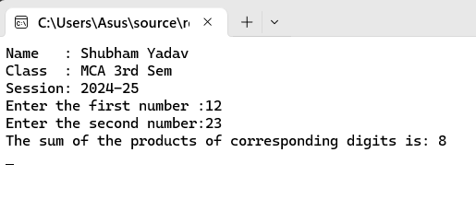
Output:

Program No..07
Program: Write a C# program to display factorial series up to nth term 1! 2! 3! 4! …… n!
Code:
using System;

namespace assighment3
{
internal class Program

{
static void Main(string[] args)

{
Console.WriteLine("Name : Shubham Yadav");
Console.WriteLine("Class : MCA 3rd Sem");
Console.WriteLine("Session: 2024-25");
Console.Write("Enter a positive integer n: ");

int n = int.Parse(Console.ReadLine());
Console.WriteLine("Factorial series up to " + n + "th term:");

for (int i = 1; i <= n; i++)
{
Console.WriteLine($"{i}! = {Factorial(i)}");
}
Console.WriteLine("Press any key to exit...");
Console.ReadLine();
}

static long Factorial(int number)
{
long result = 1;

for (int i = 2; i <= number; i++)
{
result *= i;
}
return result;
}
}
}

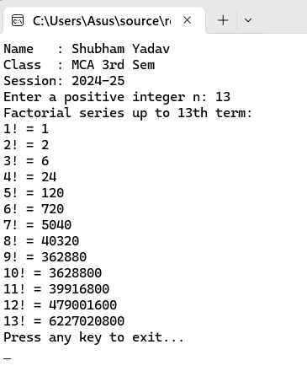
Output:

Program No..08
Program: Write the program that display Fibonacci series up to nth term. 0 1 1 2 3 5 8 13 ……n.
Code:
using System;

namespace assighment3
{
internal class Program
{
static void Main(string[] args)
{
Console.WriteLine("Name : Shubham Yadav");
Console.WriteLine("Class : MCA 3rd Sem");
Console.WriteLine("Session: 2024-25");

Console.Write("Enter a positive integer n: ");
int n = int.Parse(Console.ReadLine());

Console.WriteLine("Fibonacci series up to " + n + "th term:");
int a = 0, b = 1;
for (int i = 0; i < n; i++)
{
Console.Write(a + " ");
int next = a + b;
a = b;
b = next;
}
Console.ReadLine();
}
}
}

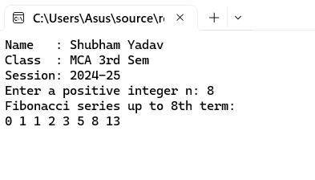
Output:

Program No..09
Program: Write a C# program to do the following operations:
Read any two positive integer operands (say op1 & op2) and one character type operator (say opr). Note that opr is any mathematical operator.
Depending upon the operator, do the appropriate operation.
Code:
using System;

namespace assighment3
{
internal class Program
{
static void Main(string[] args)
{
Console.WriteLine("Name : Shubham Yadav");
Console.WriteLine("Class : MCA 3rd Sem");
Console.WriteLine("Session: 2024-25");
Console.Write("Enter the first positive integer (op1): ");
int op1 = int.Parse(Console.ReadLine());
Console.Write("Enter the second positive integer (op2): ");
int op2 = int.Parse(Console.ReadLine());
Console.Write("Enter an operator (+, -, *, /): ");
char opr = Console.ReadLine()[0];
double result = 0;
bool validOperation = true;
switch (opr)
{
case '+':
result = op1 + op2;
break;
case '-':
result = op1 - op2;
break;
case '*':
result = op1 * op2;
break;
case '/':
if (op2 != 0)
{
result = (double)op1 / op2;
}
else
{
Console.WriteLine("Error: Division by zero is not allowed.");
validOperation = false;
}
break;
default:
Console.WriteLine("Error: Invalid operator.");
validOperation = false;
break;
}

if (validOperation)
{
Console.WriteLine($"Result: {op1} {opr} {op2} = {result}");
}
Console.ReadLine();
}
}
}

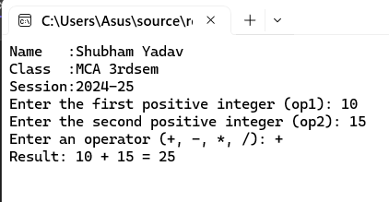
Output:

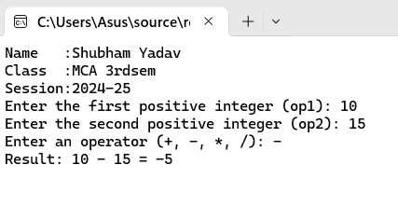

Program No..10
Program: Write a C# program to read month (1-12) and 4digited year and display total days in given month and year.
Code:
using System;

namespace assighment3
{
internal class Program
{
static void Main(string[] args)
{
Console.WriteLine("Name :Shubham Yadav");
Console.WriteLine("Class :MCA 3rdsem");
Console.WriteLine("Session:2024-25");
Console.Write("Enter month (1-12): ");
int month = int.Parse(Console.ReadLine());
Console.Write("Enter a four-digit year: ");
int year = int.Parse(Console.ReadLine());
if (month < 1 || month > 12)
{
Console.WriteLine("Invalid month. Please enter a value between 1 and 12.");
return;
}
int daysInMonth = DateTime.DaysInMonth(year, month);

Console.WriteLine($"Total days in {month}/{year}: {daysInMonth}");
Console.ReadLine();
}
}
}

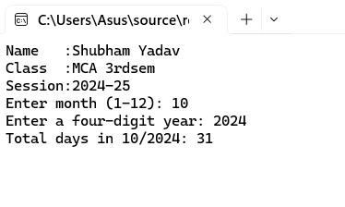
Output:

Program No..11
Program: Write a C# program that display following pattern.
N=7
1
1 1
1 1 2
1 1 2 3
1 1 2 3 5
1 1 2 3 5 8
Code:
using System;

namespace assighment3
{
internal class Program
{
static void Main(string[] args)
{
Console.WriteLine("Name :Shubham Yadav");
Console.WriteLine("Class :MCA 3rdsem");
Console.WriteLine("Session:2024-25");
int N = 7;
int a = 1, b = 1;
for (int i = 1; i < N; i++)
{
a = 1;
b = 1;
for (int j = 1; j <= i; j++)
{
Console.Write(a + " ");
int next = a + b;
a = b;
b = next;
}
Console.WriteLine();
}
Console.ReadLine();
}
}
}

Output:
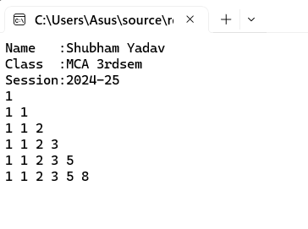

Program No..12
Program: Design the form having 1 Text box and buttons like Bold, Italic, Red & Blue, show and hide When user presses an y of this command buttons then the content of text box will be changed to red or blue or bold or italic and Clicking on the “Show” button it will display a Textbox & when user clicks on “Hide” button then it will remove the Textbox. (Use Visible Property).
Code:
using System;
using System.Collections.Generic;
using System.ComponentModel;
using System.Data;
using System.Drawing;
using System.Linq;
using System.Text;
using System.Threading.Tasks;
using System.Windows.Forms;
namespace fonrt_design
{
public partial class Form1 : Form
{
public Form1()
{
InitializeComponent();
}
private void textBox1_TextChanged(object sender, EventArgs e)
{
}

private void button1_Click(object sender, EventArgs e)
{
if(textBox1.Font.Bold != true)
{
textBox1.Font = new Font(FontFamily.GenericSerif, 12, FontStyle.Bold);
}
else
{
textBox1.Font = new Font(FontFamily.GenericSerif, 12, FontStyle.Regular);
}
}
private void button2_Click(object sender, EventArgs e)
{
if (textBox1.Font.Italic != true)
{
textBox1.Font = new Font(FontFamily.GenericSerif, 12, FontStyle.Italic);
}
else
{
textBox1.Font = new Font(FontFamily.GenericSerif, 12, FontStyle.Regular);
}
}
private void button3_Click(object sender, EventArgs e)
{
if (textBox1.ForeColor == Color.Red)
{
textBox1.ForeColor = Color.Black;
}
else
{
textBox1.ForeColor = Color.Red;
}
}
private void button4_Click(object sender, EventArgs e)
{
if (textBox1.ForeColor == Color.Blue)
{
textBox1.ForeColor = Color.Black;
}
else
{
textBox1.ForeColor = Color.Blue;
}
}
private void button5_Click(object sender, EventArgs e)
{
textBox1.Visible = true;
}
private void button6_Click(object sender, EventArgs e)
{
textBox1.Visible = false;
}
}
}

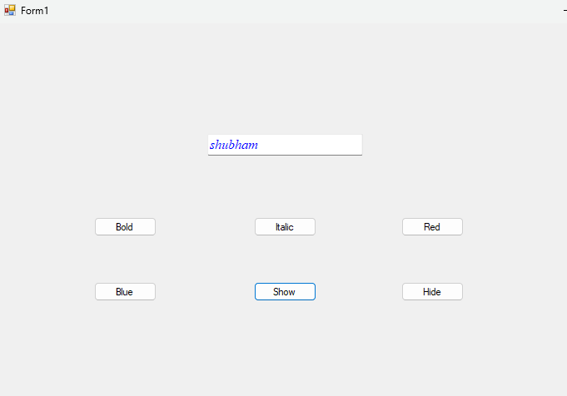
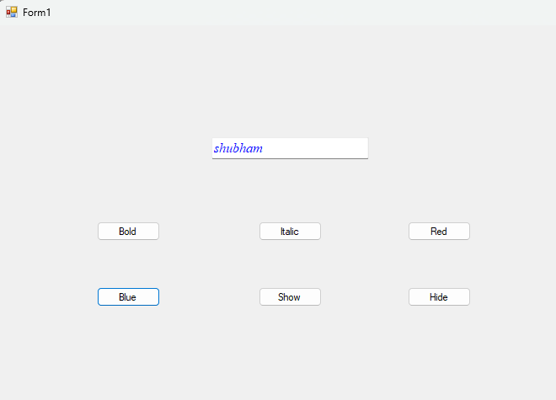
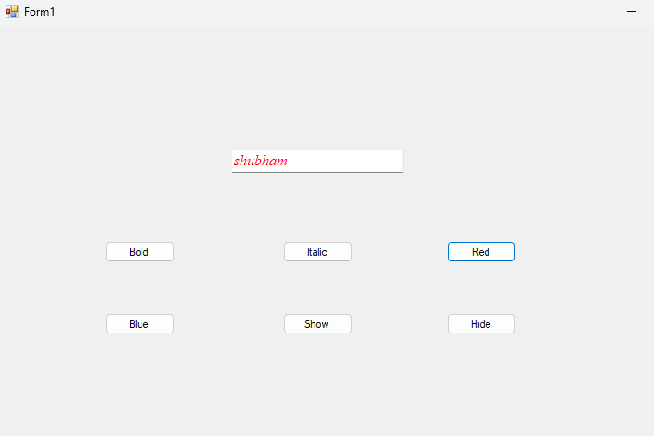
Output:
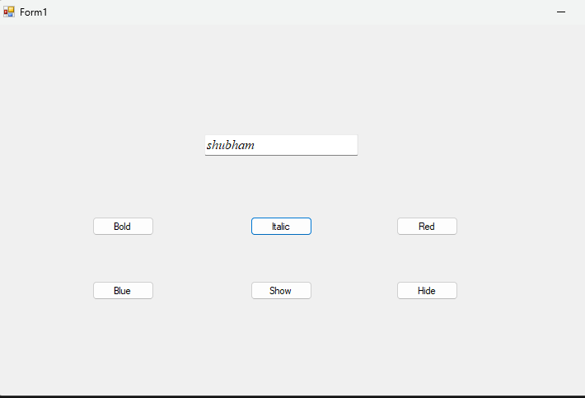
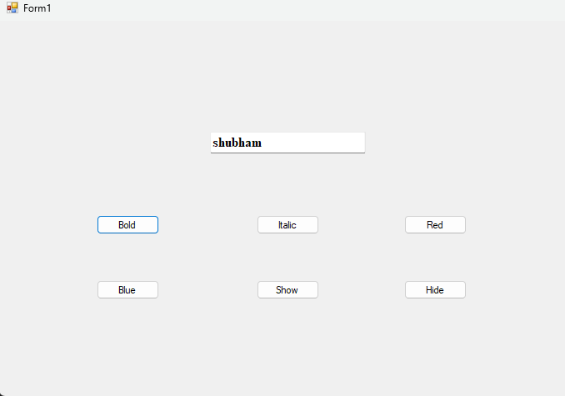

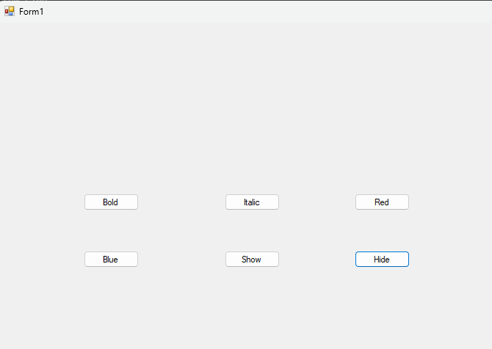

Program No..13
Program: Design the form that calculates Sum, Multiplication, Division and Subtraction of two numbers.
Code:
using System;
using System.Collections.Generic;
using System.ComponentModel;
using System.Data;
using System.Drawing;
using System.Linq;
using System.Text;
using System.Threading.Tasks;
using System.Windows.Forms;

namespace form2
{
public partial class Form1 : Form
{
public Form1()
{
InitializeComponent();
}

private void textBox1_TextChanged(object sender, EventArgs e)
{
if(float.TryParse(textBox1.Text, out float n1) && float.TryParse(textBox2.Text,out float n2))
{
label1.Text= $"Result : {n1 + n2}";
}
else
{
label1.Text = "Enter only Number";
}
}
private void button1_Click(object sender, EventArgs e)
{
if (float.TryParse(textBox1.Text, out float n1) && float.TryParse(textBox2.Text, out float n2))
{
label1.Text = $"Result : {n1 + n2}";
}
else
{
label1.Text = "Enter only Number";
}
}

private void button2_Click(object sender, EventArgs e)
{
if (float.TryParse(textBox1.Text, out float n1) && float.TryParse(textBox2.Text, out float n2))
{
label1.Text = $"Result : {n1 - n2}";
}
else
{
label1.Text = "Enter only Number";
}
}

private void button3_Click(object sender, EventArgs e)
{
if (float.TryParse(textBox1.Text, out float n1) && float.TryParse(textBox2.Text, out float n2))
{
label1.Text = $"Result : {n1 * n2}";
}
else
{
label1.Text = "Enter only Number";
}
}
private void button4_Click(object sender, EventArgs e)
{
if (float.TryParse(textBox1.Text, out float n1) && float.TryParse(textBox2.Text, out float n2))
{
label1.Text = $"Result : {n1 / n2}";
}
else
{
label1.Text = "Enter only Number";
}
}
}
}

Output:
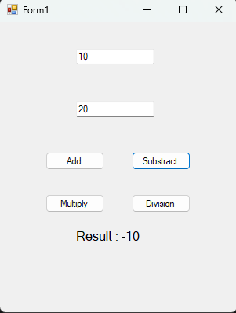
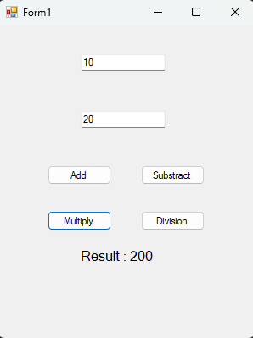
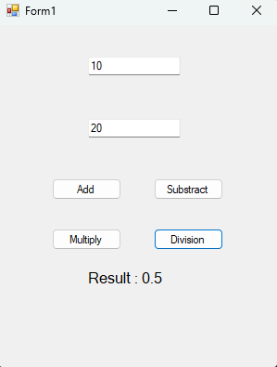
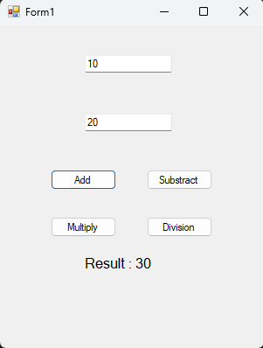

Program No..14
Program: Design the following form
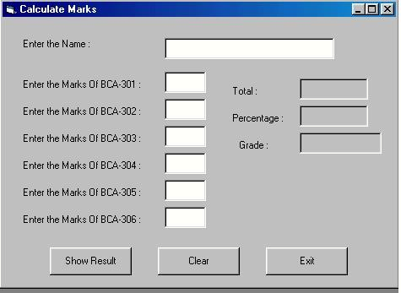

Code:-
using System;
using System.Collections.Generic;
using System.ComponentModel;
using System.Data;
using System.Drawing;
using System.Linq;
using System.Text;
using System.Threading.Tasks;
using System.Windows.Forms;
namespace shubham
{
public partial class Form1 : Form
{
public Form1()
{
InitializeComponent();
}
private void button1_Click(object sender, EventArgs e)
{
String num1 = textBox2.Text;
float number1 = float.Parse(num1);
String num2 = textBox3.Text;
float number2 = float.Parse(num2);
String num3 = textBox4.Text;
float number3 = float.Parse(num3);
String num4 = textBox5.Text;
float number4 = float.Parse(num4);
String num5 = textBox6.Text;
float number5 = float.Parse(num5);
String num6 = textBox7.Text;
float number6 = float.Parse(num6);
if (number1 >=0 && number2 >=0 && number3>=0 && number4 >=0 && number5 >=0 && number6>= 0)
{
float sum = 0;
sum = number1 + number2 + number3 + number4 + number5+number6;
textBox8.Text = sum.ToString();
float percentage=(sum*100)/600;
textBox9.Text = percentage.ToString("0.00");
if (percentage >= 90)
{
textBox10.Text = "A+";
}
else if (percentage >= 80)
{
textBox10.Text = "A";
}
else if (percentage >= 70)
{
textBox10.Text = "B+";
}
else if (percentage >= 70)
{
textBox10.Text = "B";
}
else if (percentage >= 60 )
{
textBox10.Text = "C+";
}
else if (percentage >= 50 )
{
textBox10.Text = "C";
}
else if (percentage >= 40 )
{
textBox10.Text = "D+";
}
else
{
textBox10.Text = "Fail";
}
}
}
private void button2_Click(object sender, EventArgs e)
{
textBox2.Clear();
textxBox3.Clear();
textBox4.Clear();
textBox5.Clear();
textBox6.Clear();
textBox7.Clear();
textBox8.Clear();
textBox9.Clear();
textBox10.Clear();
}
private void button3_Click(object sender, EventArgs e)
{
this.Close();
}
}
}

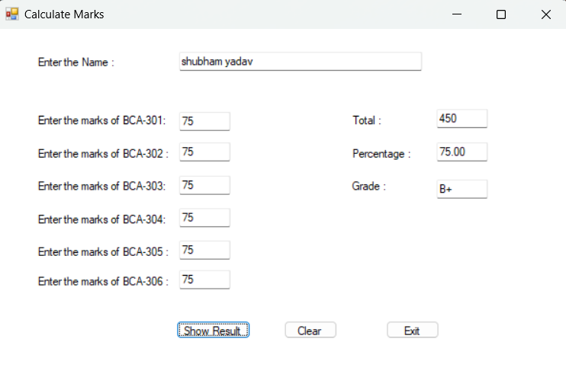
Output:-

Program No..15
Program: Design a form to create conversion calculator like
  - Decimal number to Binary, Octal & Hexadecimal.
  - Binary number to Decimal, Octal & Hexadecimal.
  - Octal number to hexa, binary ,decimal etc.
Code:-
using System;
using System.Windows.Forms;
namespace shubham2{
public partial class Form1 : Form{
public Form1(){
InitializeComponent();
}
private void textBox7_TextChanged(object sender, EventArgs e){}
private void label7_Click(object sender, EventArgs e){}
private void textBox1_TextChanged(object sender, EventArgs e){
String tsnum = textBox1.Text;
int number;
bool success = int.TryParse(tsnum, out number);
if (success){
int[] dnum = new int[32];
int[] dnum2 = new int[32];
char[] dnum3 = new char[32];
int count = 0, count1 = 0, count3 = 0;
int Dnumber = number;
for (int i = 0; Dnumber > 0; i++){
dnum[i] = Dnumber % 2;
Dnumber = Dnumber / 2;
count++;
}
int Dnumber2 = number;
for (int i = 0; Dnumber2 > 0; i++){
dnum2[i] = Dnumber2 % 8;
Dnumber2 = Dnumber2 / 8;
count1++;
}
String snum = "";
for (int i = count - 1; i >= 0; i--){
snum += dnum[i].ToString();
}
String snum1 = "";
for (int i = count1 - 1; i >= 0; i--){
snum1 += dnum2[i].ToString();
}
int Dnumber3 = number;
for (int i = 0; Dnumber3 > 0; i++){
int reminder = Dnumber3 % 16;
if (reminder < 10){
dnum3[i] = (char)('0' + reminder);
}
else{
dnum3[i] = (char)('A' + (reminder - 10));
}
Dnumber3 = Dnumber3 / 16;
count3++;
}
String snum2 = "";
for (int i = count3 - 1; i >= 0; i--){
snum2 += dnum3[i];
}
textBox3.Text = snum;
textBox2.Text = snum1;
textBox4.Text = snum2;
}
else{
textBox3.Text = "enter valid number";
textBox2.Text = "enter valid number";
textBox4.Text = "enter valid number";
}
}
private void textBox5_TextChanged(object sender, EventArgs e){
String tnum1 = textBox5.Text;
int len = tnum1.Length;
int bnum = 0;
for (int i = 0; i < len; i++){
char bit = tnum1[len - 1 - i];
int bitv = bit == '1' ? 1 : 0;
bnum += bitv * (int)Math.Pow(2, i);
}
textBox6.Text = bnum.ToString();
String octnum = tnum1;
String octv = "";
int ognum = len % 3;
if (ognum != 0){
octnum = new string('0', 3 - ognum) + octnum;
}
for (int i = 0; i < octnum.Length; i += 3){
String group = octnum.Substring(i, 3);
int dnum = Convert.ToInt32(group, 2);
octv += dnum.ToString();
}
textBox7.Text = octv;
String hnum = tnum1;
String hexv = "";
int hgnum = len % 4;
if (hgnum != 0){
hnum = new string('0', 4 - hgnum) + hnum;
}
for (int i = 0; i < hnum.Length; i += 4){
String group = hnum.Substring(i, 4);
int dnum = Convert.ToInt32(group, 2);
char hexchar = dnum < 10 ? (char)(dnum + '0') : (char)(dnum - 10 + 'A');
hexv += hexchar;
}
textBox8.Text = hexv;
}
private void textBox9_TextChanged(object sender, EventArgs e){
String tnum2 = textBox9.Text;
int len = tnum2.Length;
String bnumv = "";
for (int i = 0; i < len; i++){
int octnum = tnum2[i] - '0';
String bnum = Convert.ToString(octnum, 2).PadLeft(3, '0');
bnumv += bnum;
}
bnumv = bnumv.TrimStart('0');
textBox10.Text = bnumv;
String octalnum = tnum2;
int dnum = 0;
for (int i = 0; i < len; i++){
int digit = octalnum[len - 1 - i] - '0';
dnum += digit * (int)Math.Pow(8, i);
}
textBox11.Text = dnum.ToString();
String octalnum1 = tnum2;
String hexnum = "";
if (dnum == 0){
hexnum = "0";
}
else{
while(dnum > 0) {
int reminder = dnum % 16;
if (reminder < 10){
hexnum = (char)('0' + reminder) + hexnum;
}
else{
hexnum = (char)('A' + (reminder - 10)) + hexnum;
}
dnum = dnum / 16;
}
textBox12.Text = hexnum.ToString();
}
}
}
}

Output:-

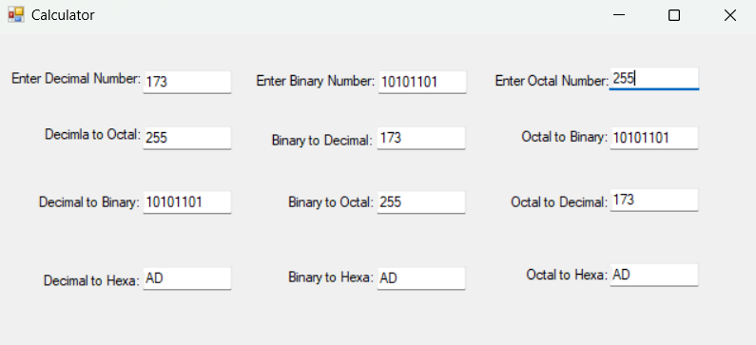

Program No..16
Program: Design the following form. So when user clicks on Radio Button then select appropriate checkbox.
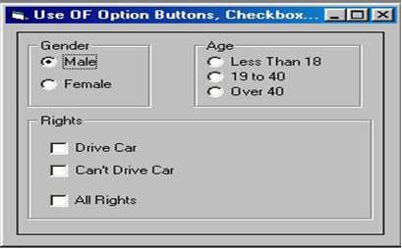

Code:-
using System;
using System.Windows.Forms;
namespace Question15
{
public partial class Form1 : Form
{
public Form1()
{
InitializeComponent();
radioButton1.CheckedChanged += radioButton_CheckedChanged;
radioButton2.CheckedChanged += radioButton_CheckedChanged;
radioButton3.CheckedChanged += radioButton_CheckedChanged;
radioButton4.CheckedChanged += radioButton_CheckedChanged;
radioButton5.CheckedChanged += radioButton_CheckedChanged;
}
private void Form1_Load(object sender, EventArgs e)
{
UpdateCheckboxes();
}
private void radioButton_CheckedChanged(object sender, EventArgs e)
{
UpdateCheckboxes();
}
private void UpdateCheckboxes()
{
if (radioButton1.Checked || radioButton2.Checked)
{
if (radioButton3.Checked)
{
checkBox1.Enabled = false;
checkBox1.Checked = false;
checkBox2.Enabled = false;
checkBox2.Checked = false;
checkBox3.Enabled = true;
checkBox3.Checked = false;
}
else if (radioButton4.Checked)
{
checkBox1.Enabled = false;
checkBox1.Checked = false;
checkBox2.Enabled = true;
checkBox2.Checked = false;
checkBox3.Enabled = false;
checkBox3.Checked = false;
}
else if (radioButton5.Checked)
{
checkBox1.Enabled = true;
checkBox1.Checked = false;
checkBox2.Enabled = false;
checkBox2.Checked = false;
checkBox3.Enabled = false;
checkBox3.Checked = false;
}
else
{
checkBox1.Enabled = false;
checkBox1.Checked = false;
checkBox2.Enabled = false;
checkBox2.Checked = false;
checkBox3.Enabled = false;
checkBox3.Checked = false;
}
}
else
{
checkBox1.Enabled = false;
checkBox1.Checked = false;
checkBox2.Enabled = false;
checkBox2.Checked = false;
checkBox3.Enabled = false;
checkBox3.Checked = false;
}
}
}
}
Output:-
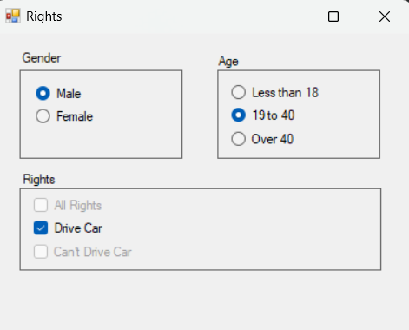
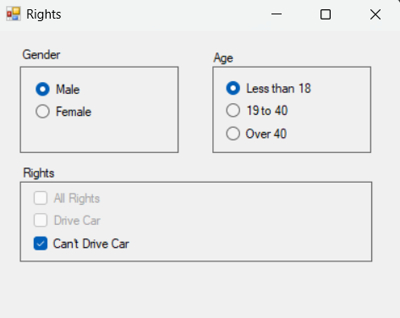

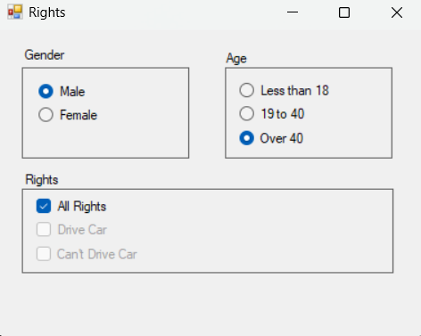

Program No...17
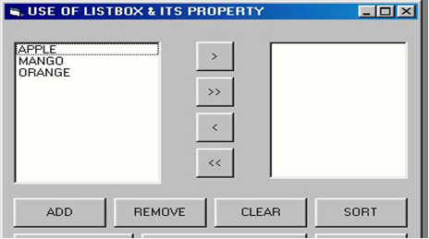
Program: program shows the functionality of listbox:

Code:-
using System;
using System.Collections.Generic;
using System.ComponentModel;
using System.Data;
using System.Drawing;
using System.Linq;
using System.Text;
using System.Threading.Tasks;
using System.Windows.Forms;
namespace Question17
{
public partial class Form1 : Form
{
public Form1()
{
InitializeComponent();
}

private void button6_Click(object sender, EventArgs e)
{
if (listBox1.SelectedItems.Count > 0)
{
String selectitem = listBox1.SelectedItem.ToString();
listBox1.Items.Remove(selectitem);
}
else if(listBox2.SelectedItems.Count > 0)
{
String selectitem1 = listBox2.SelectedItem.ToString();
listBox2.Items.Remove(selectitem1);
}
}
private void button1_Click(object sender, EventArgs e)
{
if (listBox1.SelectedItems.Count > 0)
{
String selectitem = listBox1.SelectedItem.ToString();
listBox2.Items.Add(selectitem);
listBox1.Items.Remove(selectitem);
}
}
private void button2_Click(object sender, EventArgs e)
{
List<String> list = new List<String>();
for(int i=0;i<listBox1.Items.Count;i++)
{
list.Add(listBox1.Items[i].ToString());
}
foreach (String i in list)
{
listBox2.Items.Add(i);
listBox1.Items.Remove(i);
}
}
private void button3_Click(object sender, EventArgs e)
{
if (listBox2.SelectedItems.Count > 0)
{
String selectitem = listBox2.SelectedItem.ToString();
listBox1.Items.Add(selectitem);
listBox2.Items.Remove(selectitem);
}
}
private void button4_Click(object sender, EventArgs e)
{
List<String> list = new List<String>();
for (int i = 0; i < listBox2.Items.Count; i++)
{
list.Add(listBox2.Items[i].ToString());
}
foreach (String i in list)
{
listBox1.Items.Add(i);
listBox2.Items.Remove(i);
}
}
private void button5_Click(object sender, EventArgs e)
{
listBox1.Items.Add("Apple");
listBox1.Items.Add("Banana");
listBox1.Items.Add("Orange");
listBox1.Items.Add("Graph");
listBox1.Items.Add("Coconut");
listBox1.Items.Add("Peache");
}
private void button8_Click(object sender, EventArgs e)
{
listBox1.Sorted = true;
listBox2.Sorted = true;
}
private void button7_Click(object sender, EventArgs e)
{
listBox1.Items.Clear();
listBox2.Items.Clear();
}
}
}

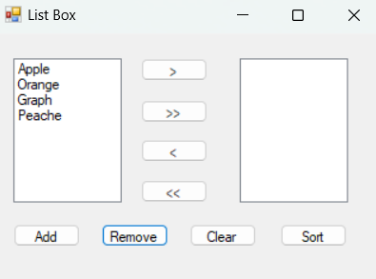
Output:-
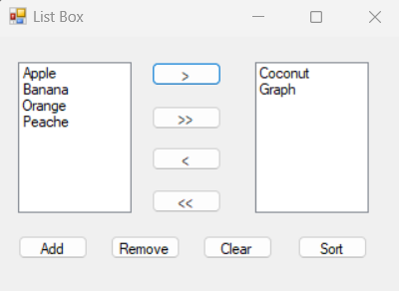
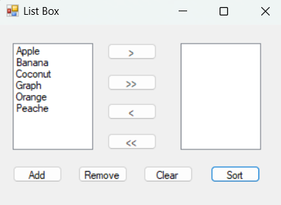
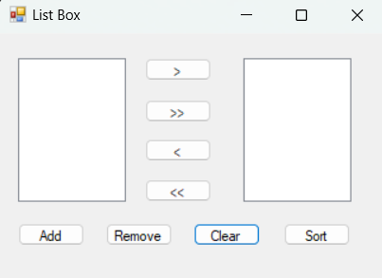

Program No..18
Program: Design one form to create application like Rich text document using 1 Rich Text box and different buttons. When user presses any of this command buttons then the selected content of Rich textbox will be changed accordingly.
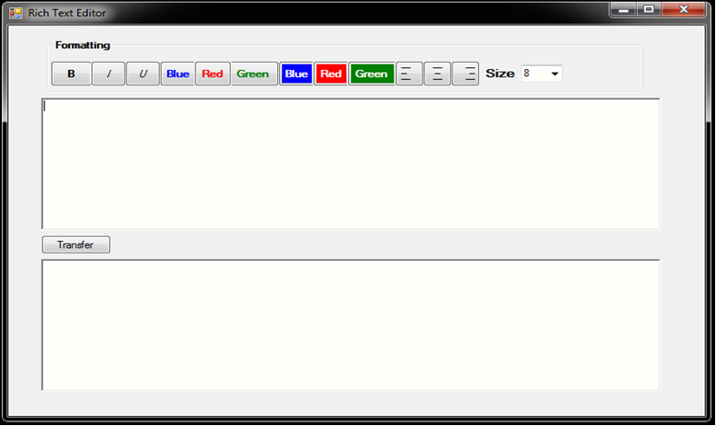

Code:-
using System;
using System.Drawing;
using System.Windows.Forms;
namespace Question18
{
public partial class Form1 : Form
{
public Form1()
{
InitializeComponent();
}
private void button1_Click(object sender, EventArgs e)
{
richTextBox1.SelectionFont = new Font(richTextBox1.SelectionFont, FontStyle.Bold);
}
private void button2_Click(object sender, EventArgs e)
{
richTextBox1.SelectionFont = new Font(richTextBox1.SelectionFont, FontStyle.Italic);
}
private void button3_Click(object sender, EventArgs e)
{
richTextBox1.SelectionFont = new Font(richTextBox1.SelectionFont, FontStyle.Underline);
}
private void button4_Click(object sender, EventArgs e)
{
richTextBox1.SelectionColor = Color.Blue;
}
private void button5_Click(object sender, EventArgs e)
{
richTextBox1.SelectionColor = Color.Red;
}
private void button6_Click(object sender, EventArgs e)
{
richTextBox1.SelectionColor = Color.Green;
}
private void button7_Click(object sender, EventArgs e)
{
richTextBox1.SelectionBackColor = Color.Blue;
}
private void button8_Click(object sender, EventArgs e)
{
richTextBox1.SelectionBackColor = Color.Red;
}
private void button9_Click(object sender, EventArgs e)
{
richTextBox1.SelectionBackColor = Color.Green;
}
private void button10_Click(object sender, EventArgs e)
{
richTextBox1.SelectionAlignment= HorizontalAlignment.Left;
}
private void button11_Click(object sender, EventArgs e)
{
richTextBox1.SelectionAlignment = HorizontalAlignment.Center;
}
private void button12_Click(object sender, EventArgs e)
{
richTextBox1.SelectionAlignment = HorizontalAlignment.Right;
}
private void listBox1_SelectedIndexChanged(object sender, EventArgs e)
{
if (listBox1.Items.Count > 0 && listBox1.SelectedItem != null)
{
string item = (string)listBox1.SelectedItem;
if (float.TryParse(item, out float selectedSize))
{
if (richTextBox1.SelectionLength > 0)
{
richTextBox1.SelectionFont = new Font(richTextBox1.SelectionFont.FontFamily, selectedSize);
}
else {
richTextBox1.SelectionFont = new Font(richTextBox1.Font.FontFamily, selectedSize);
}
}
}
}
private void Form1_Load(object sender, EventArgs e)
{
for (int size = 8; size <= 36; size += 2)
{
listBox1.Items.Add(size.ToString());
}
listBox1.SelectedItem = "12";
}
private void button13_Click(object sender, EventArgs e)
{
richTextBox2.Rtf = richTextBox1.Rtf;
richTextBox1.Clear();
}
}
}
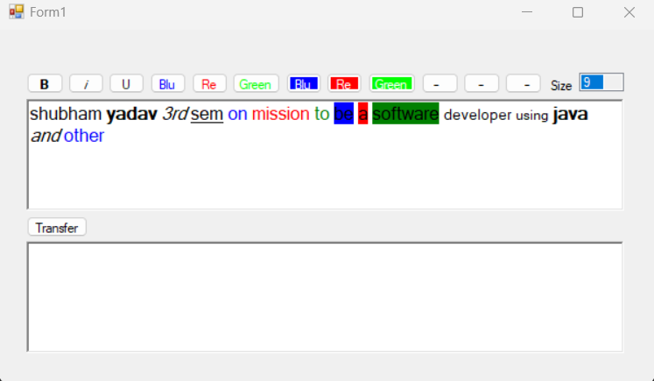
Output:-

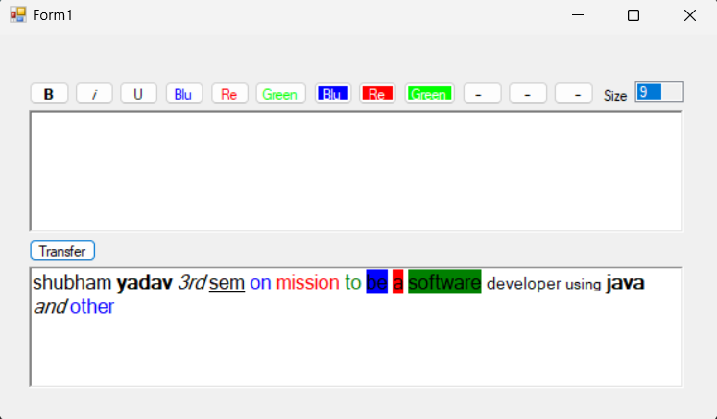

Program No..19
Program: Design the digital watch using Timer Control.

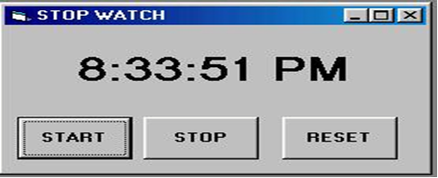
Code:-
using System;
using System.Diagnostics;
using System.Windows.Forms;
namespace Question19
{
public partial class Form1 : Form
{
private Stopwatch stopwatch = new Stopwatch();
public Form1(){
InitializeComponent();
stopwatch = new Stopwatch();
}
private void Form1_Load(object sender, EventArgs e){
Timer timer = new Timer();
timer.Interval = 100;
timer.Tick += new EventHandler(label1_Click);
timer.Start();
}
private void button1_Click(object sender, EventArgs e){
stopwatch.Start();
button1.Enabled = false;
button2.Enabled = true;
}
private void button2_Click(object sender, EventArgs e){
stopwatch.Stop();
button1.Enabled = true;
button2.Enabled = false;
}
private void button3_Click(object sender, EventArgs e) {
stopwatch.Reset();
label1.Text = "00:00:00";
button1 .Enabled = true;
button2 .Enabled = false;
}
private void label1_Click(object sender, EventArgs e){
label1.Text = stopwatch.Elapsed.ToString(@"mm\:ss\.fff");}}}
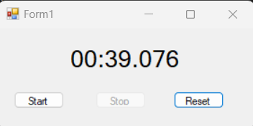
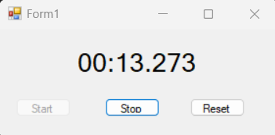
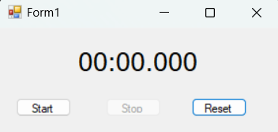
Output:-

Program No..20
Program: Design the following form using horizontal scrollbar. In this, when user click on particular scroll bar then back color of shape will be changed to Red, Green & Blue color.
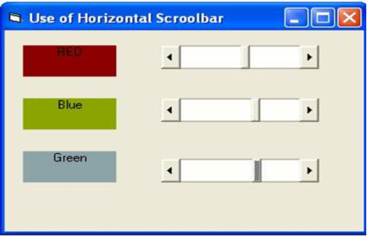
Code:-
using System;
using System.Drawing;
using System.Windows.Forms;
namespace Question20
{
public partial class Form1 : Form
{
public Form1()
{
InitializeComponent();
hScrollBar1.Maximum = 1000;
hScrollBar1.Minimum = 0;
hScrollBar2.Maximum = 1000;
hScrollBar2.Minimum = 0;
hScrollBar3.Maximum = 1000;
hScrollBar3.Minimum = 0;
}
private void hScrollBar1_Scroll(object sender, ScrollEventArgs e)
{
int scrollpos = e.NewValue;
if(scrollpos > 500)
{
label1.BackColor = Color.Red;
}
else
{
label1.BackColor = Color.Transparent;
}
}
private void hScrollBar2_Scroll(object sender, ScrollEventArgs e)
{
int scrollpos = e.NewValue;
if (scrollpos > 500)
{
label2.BackColor = Color.Blue;
}
else
{
label2.BackColor = Color.Transparent;
}
}
private void hScrollBar3_Scroll(object sender, ScrollEventArgs e)
{
int scrollpos = e.NewValue;
if (scrollpos > 500)
{
label3.BackColor = Color.Green;
}
else
{
label3.BackColor = Color.Transparent;
}
}
}
}
Output:-

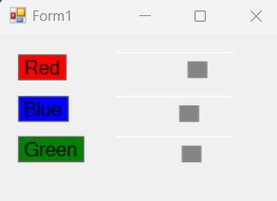

Program No..21
Program: Design the following form using vertical scrollbar. In this, when user click on particular scroll bar then back color of shape will be changed to Red, Green & Blue color.
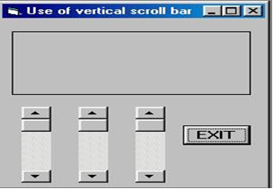
Code:-
using System;
using System.Drawing;
using System.Windows.Forms;
namespace Question21
{
public partial class Form1 : Form
{
public Form1()
{
InitializeComponent();
vScrollBar1.Maximum = 1000;
vScrollBar1.Minimum = 0;
vScrollBar2.Maximum = 1000;
vScrollBar2.Minimum = 0;
vScrollBar3.Maximum = 1000;
vScrollBar3.Minimum = 0;
}
private void Form1_Load(object sender, EventArgs e){}
private void vScrollBar1_Scroll(object sender, ScrollEventArgs e)
{
int vscrollpos = e.NewValue;
if(vscrollpos > 500)
{
panel1.BackColor = Color.Red;
}
else
{
panel1.BackColor = Color.Transparent;
}
}
private void vScrollBar2_Scroll(object sender, ScrollEventArgs e)
{
int vscrollpos = e.NewValue;
if (vscrollpos > 500)
{
panel1.BackColor = Color.Blue;
}
else
{
panel1.BackColor = Color.Transparent;
}
}
private void vScrollBar3_Scroll(object sender, ScrollEventArgs e)
{
int vscrollpos = e.NewValue;
if (vscrollpos > 500)
{
panel1.BackColor = Color.Green;
}
else
{
panel1.BackColor = Color.Transparent;
}
}
private void button1_Click(object sender, EventArgs e)
{
this.Close();
}
}
}
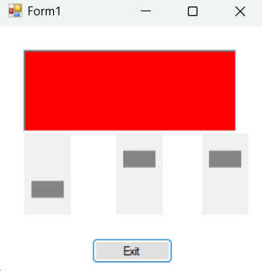
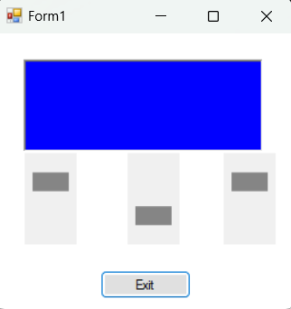
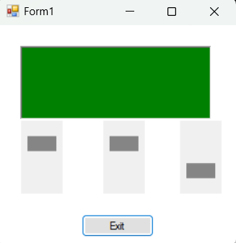
Output:-

Program No..22
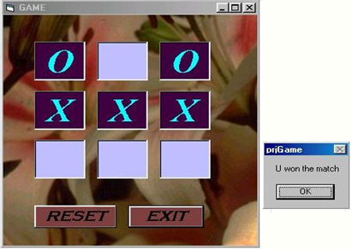
Program: Design the following Tic-tac-toe game.

Code:-
using System;
using System.Windows.Forms;
using static System.Windows.Forms.VisualStyles.VisualStyleElement;
namespace Question22
{
public partial class Form1 : Form
{
private string[] board = new string[9];
private string currentPlayer = "X";
private bool gameOver = false;
public Form1()
{
InitializeComponent();
}

private void InitializeGame()
{
for (int i = 0; i < 9; i++)
{
board[i] = string.Empty; // Empty cell
Controls["txtBox" + (i + 1)].Text = "";
}
currentPlayer = "X";
gameOver = false;
}
private bool CheckWin()
{
int[][] winPatterns = new int[][]
{
new int[] { 0, 1, 2 },
new int[] { 3, 4, 5 },
new int[] { 6, 7, 8 },
new int[] { 0, 3, 6 },
new int[] { 1, 4, 7 },
new int[] { 2, 5, 8 },
new int[] { 0, 4, 8 },
new int[] { 2, 4, 6 }
};
foreach (var pattern in winPatterns)
{
if (board[pattern[0]] == currentPlayer &&
board[pattern[1]] == currentPlayer &&
board[pattern[2]] == currentPlayer)
{
return true;
}
}
return false;
}
private bool CheckDraw()
{
foreach (var cell in board)
{
if (string.IsNullOrEmpty(cell))
{
return false;
}
}
return true;
}
private void TextBoxClicked(object sender, EventArgs e)
{
if (gameOver)
return;
System.Windows.Forms.TextBox clickedTextBox = (System.Windows.Forms.TextBox)sender;
int index = int.Parse(clickedTextBox.Name.Substring(7)) - 1; // Get index from textbox name (txtBox1, txtBox2, etc.)
if (!string.IsNullOrEmpty(board[index]))
return; // Cell already filled
board[index] = currentPlayer;
clickedTextBox.Text = currentPlayer;
if (CheckWin())
{
gameOver = true;
MessageBox.Show($"Player {currentPlayer} wins!", "Game Over", MessageBoxButtons.OK, MessageBoxIcon.Information);
DialogResult result = MessageBox.Show($"Player {currentPlayer} wins!\nDo you want to play again?",
"Game Over", MessageBoxButtons.YesNo, MessageBoxIcon.Information);
if (result == DialogResult.Yes)
{
InitializeGame();
}
else
{
Application.Exit();
}
}
else if (CheckDraw())
{
gameOver = true;
MessageBox.Show("It's a draw!", "Game Over", MessageBoxButtons.OK, MessageBoxIcon.Information);
DialogResult result = MessageBox.Show("It's a draw!\nDo you want to play again?",
"Game Over", MessageBoxButtons.YesNo, MessageBoxIcon.Information);
if (result == DialogResult.Yes)
{
InitializeGame();
}
else
{
Application.Exit();
}
}
else
{
currentPlayer = currentPlayer == "X" ? "O" : "X";
}
}
private void button1_Click(object sender, EventArgs e)
{
InitializeGame();
}
private void button2_Click(object sender, EventArgs e)
{
Application.Exit();
}
private void Form1_Load(object sender, EventArgs e)
{
textBox1.Click += TextBoxClicked;
textBox2.Click += TextBoxClicked;
textBox3.Click += TextBoxClicked;
textBox4.Click += TextBoxClicked;
textBox5.Click += TextBoxClicked;
textBox6.Click += TextBoxClicked;
textBox7.Click += TextBoxClicked;
textBox8.Click += TextBoxClicked;
textBox9.Click += TextBoxClicked;
}
}
}

Output:-
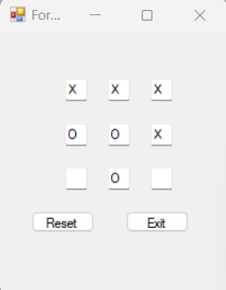

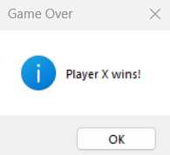

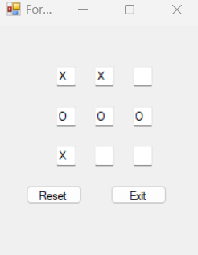

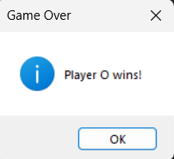

Program No..23
Program: Write a .Net console application to store student details in file and display it in console.
Code:-
using System;
using System.Collections.Generic;
using System.IO;
namespace StudentDetailsApp
{
class Program
{
public class Student
{
public string Name { get; set; }
public int RollNumber { get; set; }
public string Course { get; set; }
public Student(string name, int rollNumber, string course)
{
Name = name;
RollNumber = rollNumber;
Course = course;
}
public override string ToString()
{
return $"Name: {Name}, Roll Number: {RollNumber}, Course: {Course}";
}
}
static void Main(string[] args)
{
string filePath = "students.txt";
List<Student> students = new List<Student>();
Console.WriteLine("How many students do you want to enter?");
int numStudents;
while (!int.TryParse(Console.ReadLine(), out numStudents) || numStudents <= 0)
{
Console.WriteLine("Please enter a valid number of students.");
}
for (int i = 0; i < numStudents; i++)
{
Console.WriteLine($"\nEnter details for student {i + 1}:");
Console.Write("Enter Name: ");
string name = Console.ReadLine();
Console.Write("Enter Roll Number: ");
int rollNumber;
while (!int.TryParse(Console.ReadLine(), out rollNumber) || rollNumber <= 0)
{
Console.Write("Please enter a valid roll number: ");
}
Console.Write("Enter Course: ");
string course = Console.ReadLine();
students.Add(new Student(name, rollNumber, course));
}
WriteStudentsToFile(students, filePath);
Console.WriteLine("\nStudent Details from File:");
ReadStudentsFromFile(filePath);
Console.ReadLine();
}

static void WriteStudentsToFile(List<Student> students, string filePath)
{
using (StreamWriter writer = new StreamWriter(filePath))
{
foreach (var student in students)
{
writer.WriteLine($"{student.Name},{student.RollNumber},{student.Course}");
}
}
Console.WriteLine("Student details have been saved to the file.");
}
static void ReadStudentsFromFile(string filePath)
{
if (File.Exists(filePath))
{
using (StreamReader reader = new StreamReader(filePath))
{
string line;
while ((line = reader.ReadLine()) != null)
{
var studentDetails = line.Split(',');
Console.WriteLine($"Name: {studentDetails[0]}, Roll Number: {studentDetails[1]}, Course: {studentDetails[2]}");
}
}
}
else
{
Console.WriteLine("No student details file found.");
}
}
}
}
Output:-
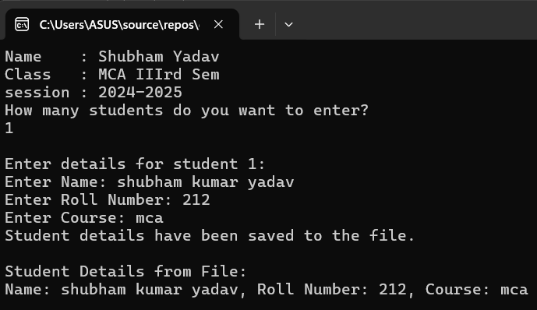

Program No..24
Program: Write a .Net window application to enter the student details in form with proper GUI component and store in a file and display in another form.
Code:-
Form 1 :
using System;
using System.Collections.Generic;
using System.ComponentModel;
using System.Data;
using System.Drawing;
using System.IO;
using System.Linq;
using System.Text;
using System.Threading.Tasks;
using System.Windows.Forms;
namespace Question24
{
public partial class Form1 : Form
{
public Form1()
{
InitializeComponent();
}
private void button2_Click(object sender, EventArgs e)
{
textBox1.Clear();
textBox2.Clear();
textBox3.Clear();
textBox4.Clear();
textBox5.Clear();
}
private void button1_Click(object sender, EventArgs e)
{
String path = "Studentnew.txt";
String name = textBox1.Text;
string Sclass = listBox1.SelectedItem != null ? (string)listBox1.SelectedItem : "Not Selected";
string Type = listBox2.SelectedItem != null ? (string)listBox2.SelectedItem : "Not Selected";
String Fname = textBox2.Text;
String Mname = textBox3.Text;
String DOB = textBox4.Text;
String Num = textBox5.Text;
long mnum = Convert.ToInt64(Num);
string data = $"{name}, {Sclass}, {Type}, {Fname}, {Mname}, {DOB}, {mnum}";
try
{
using (StreamWriter writer = new StreamWriter(path, append: true))
{
writer.WriteLine(data);
}
MessageBox.Show("Details Saved");
Form2 f2 = new Form2();
f2.Show();
this.Close();
}
catch (Exception ex)
{
MessageBox.Show(ex.Message);
}
}
}
}
Form 2:
using System;
using System.Collections.Generic;
using System.ComponentModel;
using System.Data;
using System.Drawing;
using System.IO;
using System.Linq;
using System.Runtime.InteropServices;
using System.Text;
using System.Threading.Tasks;
using System.Windows.Forms;
namespace Question24
{
public partial class Form2 : Form
{
public Form2()
{
InitializeComponent();
}
private void Form2_Load(object sender, EventArgs e)
{
String path = "Studentnew.txt";
try
{
if (File.Exists(path))
{
String[] lines = File.ReadAllLines(path);
if (lines.Length > 0)
{
String detailsold = lines[lines.Length - 1];
String[] details = detailsold.Split(new[] { ", " }, StringSplitOptions.None);
if (details.Length == 7)
{
textBox1.Text = details[0];
textBox2.Text = details[1];
textBox3.Text = details[2];
textBox4.Text = details[3];
textBox5.Text = details[4];
textBox6.Text = details[5];
textBox7.Text = details[6];
}
}
}
else
{
MessageBox.Show("File does not exist.");
}
}
catch (Exception ex)
{
MessageBox.Show(ex.Message);
}
}

private void button1_Click(object sender, EventArgs e)
{
Application.Exit();
}
}
}
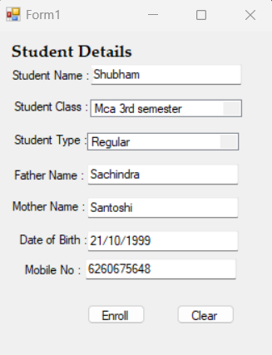
Output:-

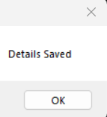

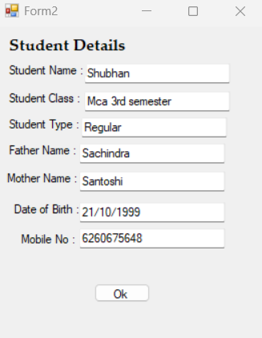

Program No..25
Program: Write an ASP.Net program to implement the validation controls.
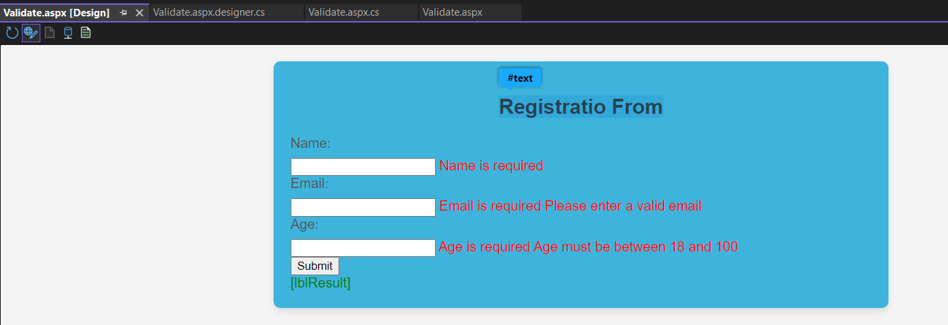

Code:-
<%@ Page Language="C#" AutoEventWireup="true" CodeBehind="validation.aspx.cs" Inherits="WebApplication4.validation" %>
<!DOCTYPE html>
<html xmlns="http://www.w3.org/1999/xhtml">
<head runat="server">
<title>ASP.NET validation controls</title>
<style type="text/css">
body {
font-family: Arial, sans-serif;
background-color: #f4f4f4;
margin: 0;
padding: 0;
}
form {
width: 50%;
margin: 20px auto;
background-color: #3eb4dd;
padding: 20px;
box-shadow: 0 4px 8px rgba(0, 0, 0, 0.1);
border-radius: 8px;
}
h2 {
text-align: center;
color: #333;
font-size: 24px;
margin-bottom: 20px;
}
label {
display: block;
margin-bottom: 8px;
color: #555;
font-size: 16px;
}
.validation-error {
color: red;
font-size: 14px;
}
.form-control {
width: 100%;
padding: 10px;
margin-bottom: 15px;
border: 1px solid #ccc;
border-radius: 4px;
font-size: 16px;
color: #333;
}
.form-control:focus {
border-color: #007bff;
outline: dashed;
}
.submit-btn {
background-color: #0649e2;
color: #0649e2;
border: none;
padding: 10px 20px;
font-size: 16px;
border-radius: 4px;
cursor: pointer;
width: 100%;
margin-top: 10px;
}
.submit-btn:hover {
background-color: #218838;
}
.result {
text-align: center;
font-size: 16px;
font-weight: bold;
margin-top: 20px;
}

.result.success {
color: green;
}
.result.error {
color: red;
}
.form-group {
margin-bottom: 20px;
}
</style>
</head>
<body>
<form id="form1" runat="server">
<h2> Registratio From</h2>
<div>
<label for="txtName">Name:</label>
<asp:TextBox ID="txtName" runat="server" MaxLength="50"></asp:TextBox>
<asp:RequiredFieldValidator
ID="rfvName"
runat="server"
ControlToValidate="txtName"
InitialValue=""
ErrorMessage="Name is required"
ForeColor="Red" />
</div>
<div>
<label for="txtEmail">Email:</label>
<asp:TextBox ID="txtEmail" runat="server" MaxLength="100"></asp:TextBox>
<asp:RequiredFieldValidator
ID="rfvEmail"
runat="server"
ControlToValidate="txtEmail"
InitialValue=""
ErrorMessage="Email is required"
ForeColor="Red" />
<asp:RegularExpressionValidator
ID="revEmail"
runat="server"
ControlToValidate="txtEmail"
ValidationExpression="^[\w-]+(\.[\w-]+)*@([\w-]+\.)+[a-zA-Z]{2,7}$"
ErrorMessage="Please enter a valid email"
ForeColor="Red" />
</div>
<div>
<label for="txtAge">Age:</label>
<asp:TextBox ID="txtAge" runat="server"></asp:TextBox>
<asp:RequiredFieldValidator
ID="rfvAge"
runat="server"
ControlToValidate="txtAge"
InitialValue=""
ErrorMessage="Age is required"
ForeColor="Red" />
<asp:RangeValidator
ID="rvAge"
runat="server"
ControlToValidate="txtAge"
MinimumValue="18"
MaximumValue="100"
Type="Integer"
ErrorMessage="Age must be between 18 and 100"
ForeColor="Red" />
</div>
<div>
<asp:Button ID="btnSubmit" runat="server" Text="Submit" OnClick="btnSubmit_Click" />
</div>
<div>
<asp:Label ID="lblResult" runat="server" ForeColor="Green"></asp:Label>
</div>
</form>
</body>
</html>
Code Behind Logic
using System;
using System.Collections.Generic;
using System.Linq;
using System.Web;
using System.Web.UI;
using System.Web.UI.WebControls;
namespace WebApplication4
{
public partial class validation : System.Web.UI.Page
{
protected void Page_Load(object sender, EventArgs e)
{}
protected void btnSubmit_Click(object sender, EventArgs e)
{
// Check if the page is valid (i.e., all validation controls are satisfied)
if (Page.IsValid)
{
// If valid, show success message
lblResult.Text = "Form submitted successfully!";
}
else
{
// If invalid, show error message
lblResult.Text = "Please correct the errors and try again.";
}
}
}
}
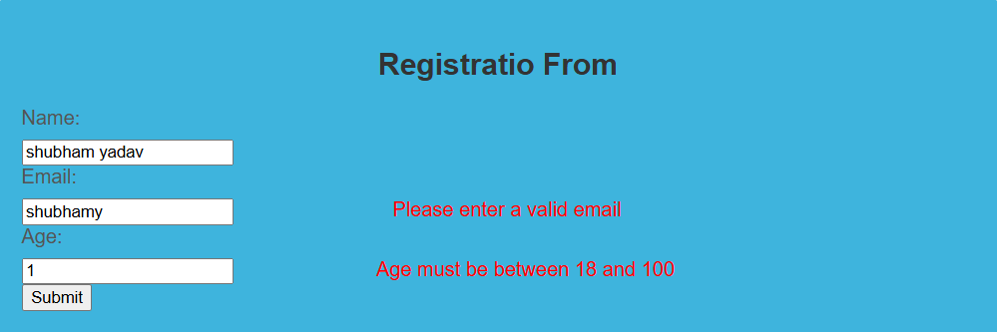

Input & Output:-

Program No..26
Program: Write a console application to generate even and odd series.
Code:-
using System;
using System.Collections.Generic;
using System.Linq;
using System.Text;
using System.Threading.Tasks;
namespace question26
{
internal class Program
{
static void Main(string[] args)
{
Console.Write("Enter last number for even and odd :");
String number=Console.ReadLine();
int dnunmber = Convert.ToInt32(number);
Console.WriteLine("Even Number:");
for (int i = 0; i < dnunmber; i++)
{
int mnumber = i % 2;
if (mnumber == 0)
{
Console.WriteLine(i);
}
}
Console.WriteLine("Odd Number:");
for (int i = 0; i < dnunmber; i++)
{
int mnumber = i % 2;
if (mnumber != 0)
{
Console.WriteLine(i);
}
}
}
}
}
Output:-
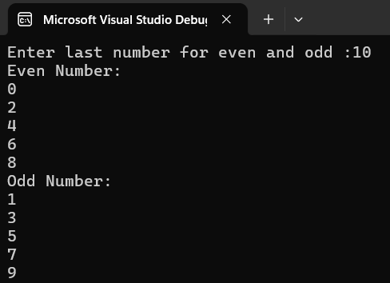

Program No.27
Program: Create following table
Student(id, name, course, DOB, address)
Write C# application to
- Add records
- view all the records
- Delete the particular record
- View all the student who are studying in course MCA
Code:
using System;
using System.Collections.Generic;
using System.Windows.Forms;
using MySql.Data.MySqlClient;
using static Question27.Form1;
namespace Question27
{
public partial class Form1 : Form
{
private string connectionString = "server=localhost;uid=root;pwd=admin;database=student_detail";
public Form1()
{
InitializeComponent();
}
public class student
{
public int Id { get; set; }
public string Name { get; set; }
public string Course { get; set; }
public DateTime DOB { get; set; }
public string Address { get; set; }
public student(int id, string name, string course, DateTime dob, string address)
{
Id = id;
Name = name;
Course = course;
DOB = dob;
Address = address;
}
}
private void button1_Click(object sender, EventArgs e)
{
try
{
int id = int.Parse(textBox1.Text);
string name = textBox2.Text;
string course = textBox3.Text;
string address = textBox4.Text;
DateTime dob = dateTimePicker1.Value;
MySqlConnection connection = new MySqlConnection(connectionString);
connection.Open();
string query = "INSERT INTO student (id,name,course,dob,address) VALUES (@id,@name,@course,@dob,@address)";
MySqlCommand cmd = new MySqlCommand(query, connection);
cmd.Parameters.AddWithValue("@id", id);
cmd.Parameters.AddWithValue("@name", name);
cmd.Parameters.AddWithValue("@course", course);
cmd.Parameters.AddWithValue("@dob", dob);
cmd.Parameters.AddWithValue("@address", address);
cmd.ExecuteNonQuery();
connection.Close();
MessageBox.Show("student added succesfully");
ClearFields();
}
catch (Exception ex)
{
MessageBox.Show("Error: "+ex.Message);
}
}
private void button2_Click(object sender, EventArgs e)
{
try
{
int id = int.Parse(textBox1.Text);
MySqlConnection connection = new MySqlConnection(connectionString);
connection.Open();
string query = "DELETE FROM student WHERE id = @id";
MySqlCommand cmd = new MySqlCommand( query, connection);
cmd.Parameters.AddWithValue("@id", id);
int rowsAffected = cmd.ExecuteNonQuery();
if (rowsAffected > 0)
{
MessageBox.Show("student delete succesfully");
}
else
{
MessageBox.Show("student not found");
}

ClearFields();
}
catch(Exception ex)
{
MessageBox.Show("Error :" + ex.Message);
}
}
private void button3_Click(object sender, EventArgs e)
{
List<student> students = new List<student>();
MySqlConnection connection = new MySqlConnection(connectionString);
connection.Open();
string query = "SELECT * FROM student";
MySqlCommand cmd = new MySqlCommand(query, connection);
MySqlDataReader reader = cmd.ExecuteReader();
while (reader.Read())
{
int id = reader.GetInt32("id");
string name = reader.GetString("name");
string course = reader.GetString("course");
DateTime dob = reader.GetDateTime("dob");
string address = reader.GetString("address");
students.Add(new student(id, name, course, dob, address));
}
connection.Close();
dataGridView1.DataSource = students;
}
private void button4_Click(object sender, EventArgs e)
{
List<student> mcaStudents = new List<student>();
MySqlConnection connection = new MySqlConnection(connectionString);
connection.Open();
string query = "SELECT * FROM student WHERE course = 'MCA'";
MySqlCommand cmd = new MySqlCommand(query, connection);
MySqlDataReader reader = cmd.ExecuteReader();
while (reader.Read())
{
int id = reader.GetInt32("id");
string name = reader.GetString("name");
string course = reader.GetString("course");
DateTime dob = reader.GetDateTime("dob");
string address = reader.GetString("address");
mcaStudents.Add(new student(id, name, course, dob, address));
}
connection.Close();
dataGridView1.DataSource = mcaStudents;
}
private void ClearFields()
{
textBox1.Clear();
textBox2.Clear();
textBox3.Clear();
textBox4.Clear();
}
}
}

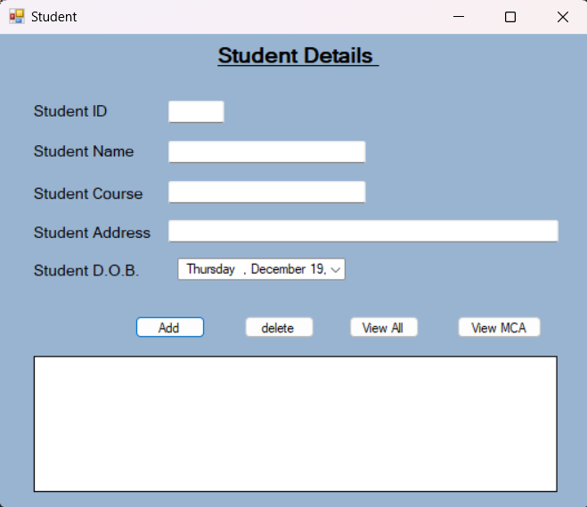
Output:-

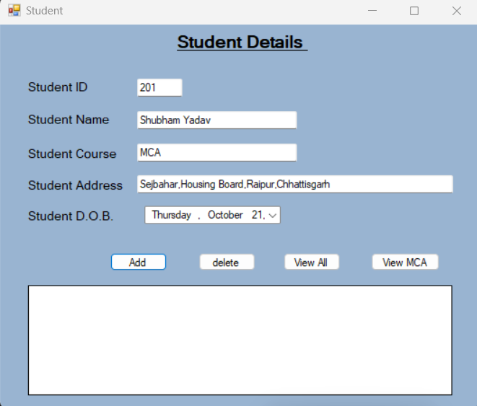
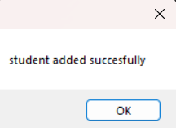

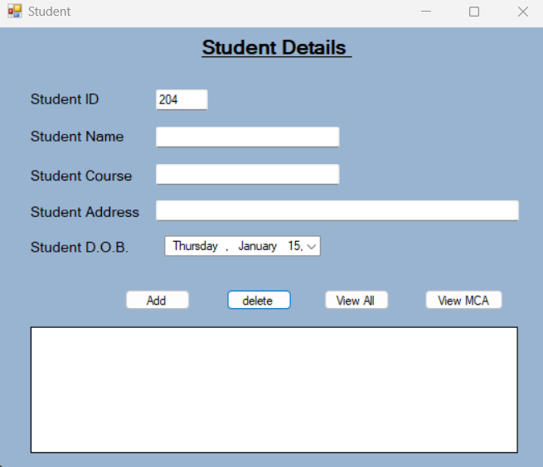

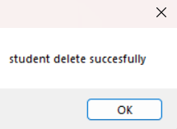

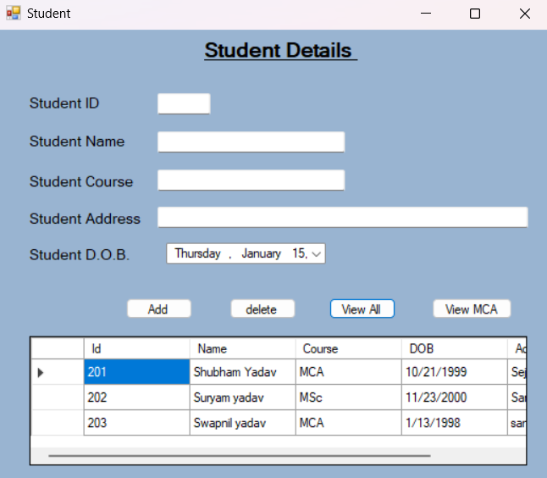

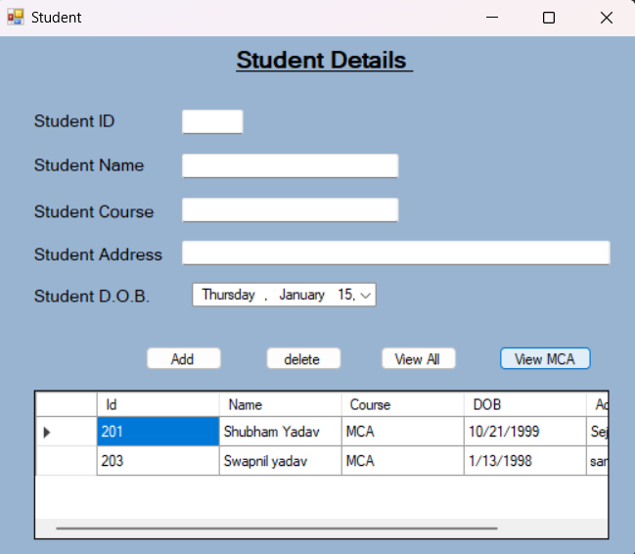

Program No.28
Program: Write a simple ASP.NET program to display the following Web Controls:
1. A button with text “click me”. The button control must be in the center of the form.
2. A label with a text hello
3. A checkbox.
The form name must be Web Controls
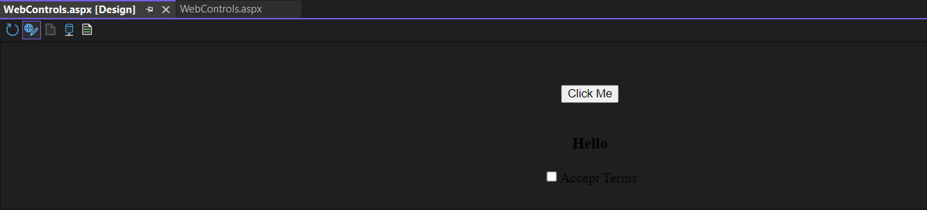
Code:-
<%@ Page Language="C#" AutoEventWireup="true" CodeBehind="WebControls.aspx.cs" Inherits="question_31.WebControls" %>
<!DOCTYPE html>
<html xmlns="http://www.w3.org/1999/xhtml">
<head runat="server">
<title>Web Controls</title>
<style type="text/css">
.center {
text-align:center;
margin-top: 50px;
}
</style>
</head>
<body>
<form id="form1" runat="server">
<div class="center">
<asp:Button ID="Button1" runat="server" Text="Click Me" OnClick="Button1_Click" /><br class="Apple-interchange-newline">
<br /><br />
<asp:Label ID="Label1" runat="server" Text="Hello" Font-Bold="true" Font-Size="Large"></asp:Label><br /><br />
<asp:CheckBox ID="CheckBox1" runat="server" Text="Accept Terms" /><br class="Apple-interchange-newline">
<br />
</div>
</form>
</body>
</html>
Code Behind Logic:-
using System;
using System.Collections.Generic;
using System.Linq;
using System.Web;
using System.Web.UI;
using System.Web.UI.WebControls;
namespace question_31
{
public partial class WebControls : System.Web.UI.Page
{
protected void Page_Load(object sender, EventArgs e)
{
}
protected void Button1_Click(object sender, EventArgs e)
{
// You can handle the button click logic here, like displaying a message.
Response.Write("<script>alert('Button clicked!');</script>");
}
}
}
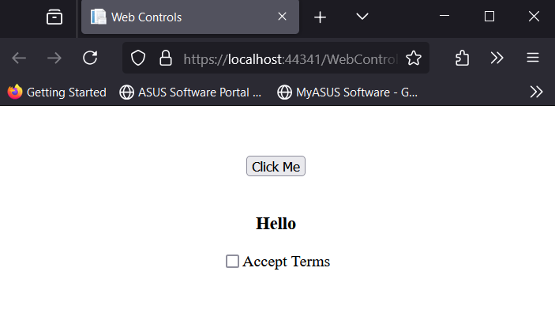
Output:-

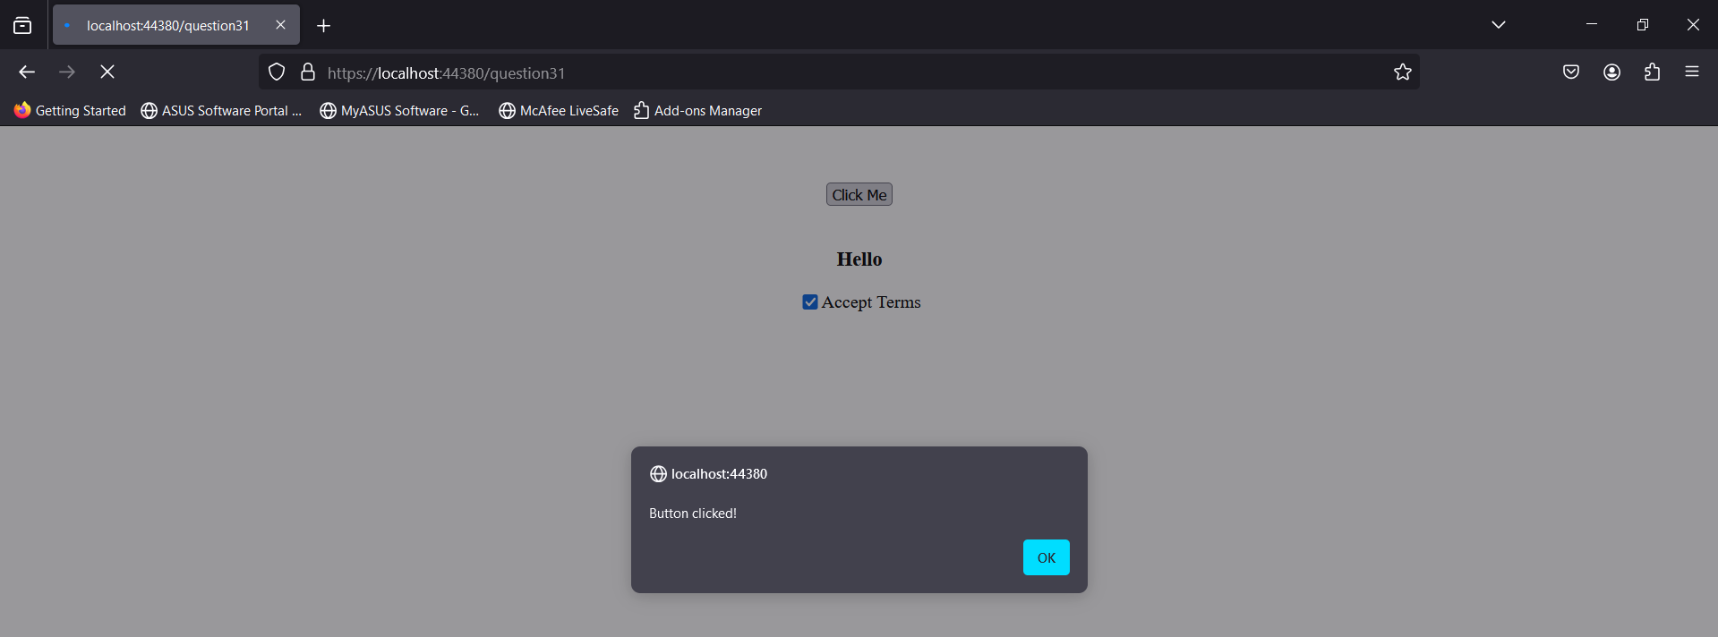

Program No.29
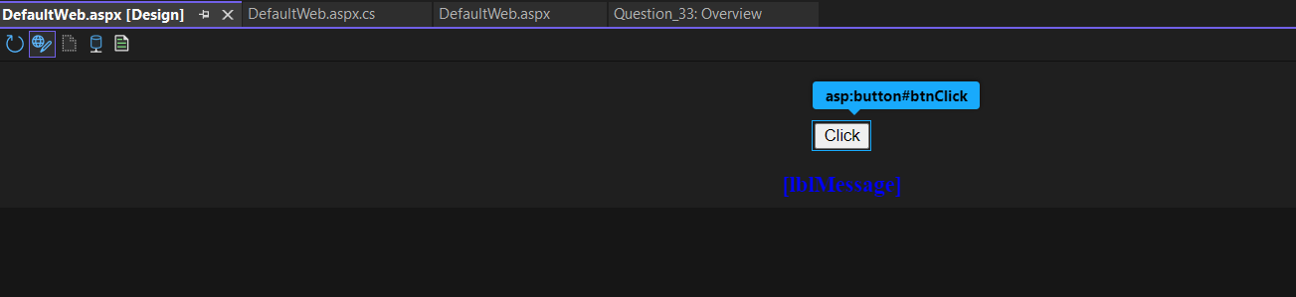
Program: Write a program to display “Welcome To Radiant” in the form when the “click” button is clicked. The form title must be ASP.NET.

Code:-
<%@ Page Language="C#" AutoEventWireup="true" CodeBehind="DefaultWeb.aspx.cs" Inherits="Question_33.DefaultWeb" %>
<!DOCTYPE html>
<html xmlns="http://www.w3.org/1999/xhtml">
<head runat="server">
<title>ASP.NET</title>
<style type="text/css">
.center {
text-align: center;
margin-top: 50px;
}
</style>
</head>
<body>
<form id="form1" runat="server">
<div class="center">
<!-- Button to trigger the event -->
<asp:Button ID="btnClick" runat="server" Text="Click" OnClick="btnClick_Click" /><br /><br />

<!-- Label to display the message -->
<asp:Label ID="lblMessage" runat="server" Text="" Font-Bold="true" Font-Size="Large" ForeColor="Blue"></asp:Label>
</div>
</form>
</body>
</html>
Code Behind Logic:-
using System;
using System.Collections.Generic;
using System.Linq;
using System.Web;
using System.Web.UI;
using System.Web.UI.WebControls;
namespace Question_33
{
public partial class DefaultWeb : System.Web.UI.Page
{
protected void Page_Load(object sender, EventArgs e)
{
}
protected void btnClick_Click(object sender, EventArgs e)
{
// Set the text of the label to "Welcome To Radiant" when the button is clicked
lblMessage.Text = "Welcome To Radiant";
}
}
}

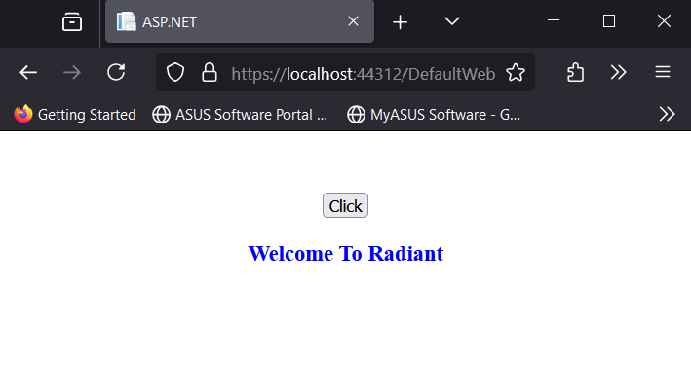
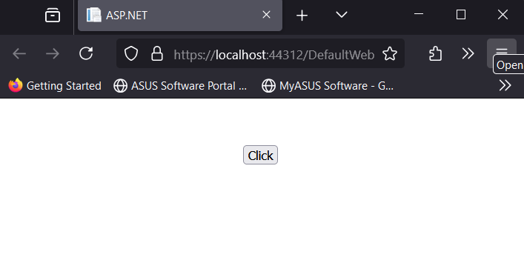
Output:-

Program No.30
Program: Write a program containing the following controls:
1. A List Box
2. A Button
3. An Image
4. A Label
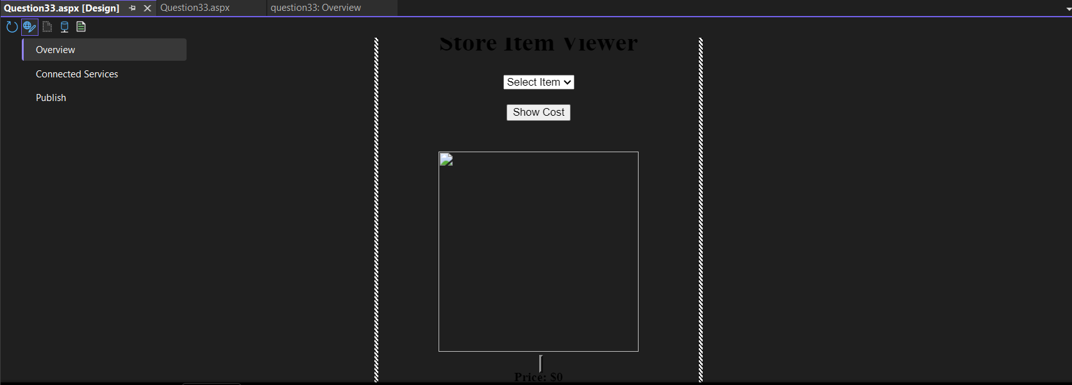
The list box is used to list items available in a store. When the user clicks on an item in the list box, its image is displayed in the image control. When the user clicks the button, the cost of the selected item is displayed in the control.

Code:-
<%@ Page Language="C#" AutoEventWireup="true" CodeBehind="Question33.aspx.cs" Inherits="question33.Question33" %>
<!DOCTYPE html>
<html xmlns="http://www.w3.org/1999/xhtml">
<head runat="server">
<meta charset="utf-8" />
<title>Store Item Viewer</title>
<style>
.container {
width: 400px;
margin: auto;
text-align: center;
}
.item-image {
width: 250px;
height: 250px;
margin-top: 20px;
}
</style>
</head>
<body>
<form id="form1" runat="server">
<div class="container">
<h1>Store Item Viewer</h1>
<!-- Dropdown to select store items -->
<asp:DropDownList ID="ddlItems" runat="server" AutoPostBack="True" OnSelectedIndexChanged="ddlItems_SelectedIndexChanged">
<asp:ListItem Text="Select Item" Value="0" />
<asp:ListItem Text="Laptop" Value="Laptop" />
<asp:ListItem Text="Mouse" Value="Mouse" />
<asp:ListItem Text="Typewriter" Value="Typewriter" />
</asp:DropDownList>
<br /><br />
<!-- Button to display cost -->
<asp:Button ID="btnShowCost" runat="server" Text="Show Cost" OnClick="btnShowCost_Click" />
<br /><br />
<!-- Image control to display the selected item's image -->
<asp:Image ID="imgItem" runat="server" CssClass="item-image" />
<br /><br />
<!-- Label to show the cost of the selected item -->
<asp:Label ID="lblPrice" runat="server" Text="Price: $0" Font-Bold="True" Font-Size="Medium" />
</div>
</form>
</body>
</html>
Code Behind Logic:-
using System;
using System.Collections.Generic;
using System.Web.UI;

namespace question33
{
public partial class Question33 : System.Web.UI.Page
{
// Prices for items
private static readonly Dictionary<string, decimal> itemPrices = new Dictionary<string, decimal>
{
{ "Laptop", 999.99m },
{ "Mouse", 25.99m },
{ "Typewriter", 150.00m }
};

// Image URLs for items
private static readonly Dictionary<string, string> itemImages = new Dictionary<string, string>
{
{ "Laptop", "images/anete-lusina-zwsHjakE_iI-unsplash.jpg" },
{ "Mouse", "images/oscar-ivan-esquivel-arteaga-ZtxED1cpB1E-unsplash.jpg" },
{ "Typewriter", "images/bernard-hermant-qTpc0Vj4YoE-unsplash.jpg" }
};

protected void Page_Load(object sender, EventArgs e)
{
if (!IsPostBack)
{
// Set initial image and cost as the first item in the list (Laptop)
imgItem.ImageUrl = itemImages["Laptop"];
lblPrice.Text = "Cost: $" + itemPrices["Laptop"].ToString("F2");

// Set initial selection in DropDownList
ddlItems.SelectedValue = "Laptop";
}
}

// Event handler for DropDownList selection change
protected void ddlItems_SelectedIndexChanged(object sender, EventArgs e)
{
string selectedItem = ddlItems.SelectedValue;
if (itemImages.ContainsKey(selectedItem))
{
imgItem.ImageUrl = itemImages[selectedItem];
}
}

// Event handler for Button click to show the selected item's cost
protected void btnShowCost_Click(object sender, EventArgs e)
{
string selectedItem = ddlItems.SelectedValue;
if (itemPrices.ContainsKey(selectedItem))
{
decimal cost = itemPrices[selectedItem];
lblPrice.Text = "Cost: $" + cost.ToString("F2");
}
}
}
}
Output:-
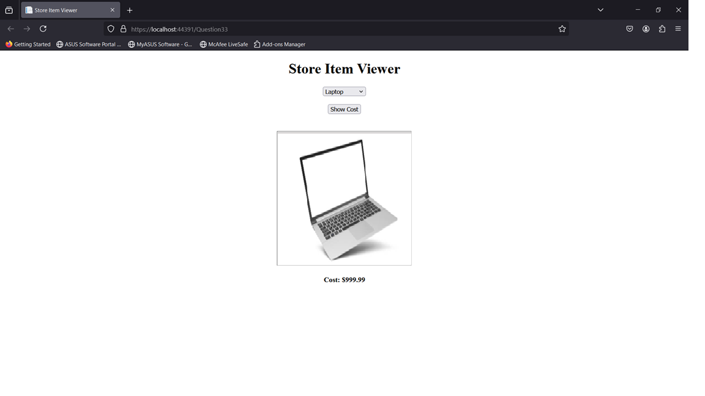

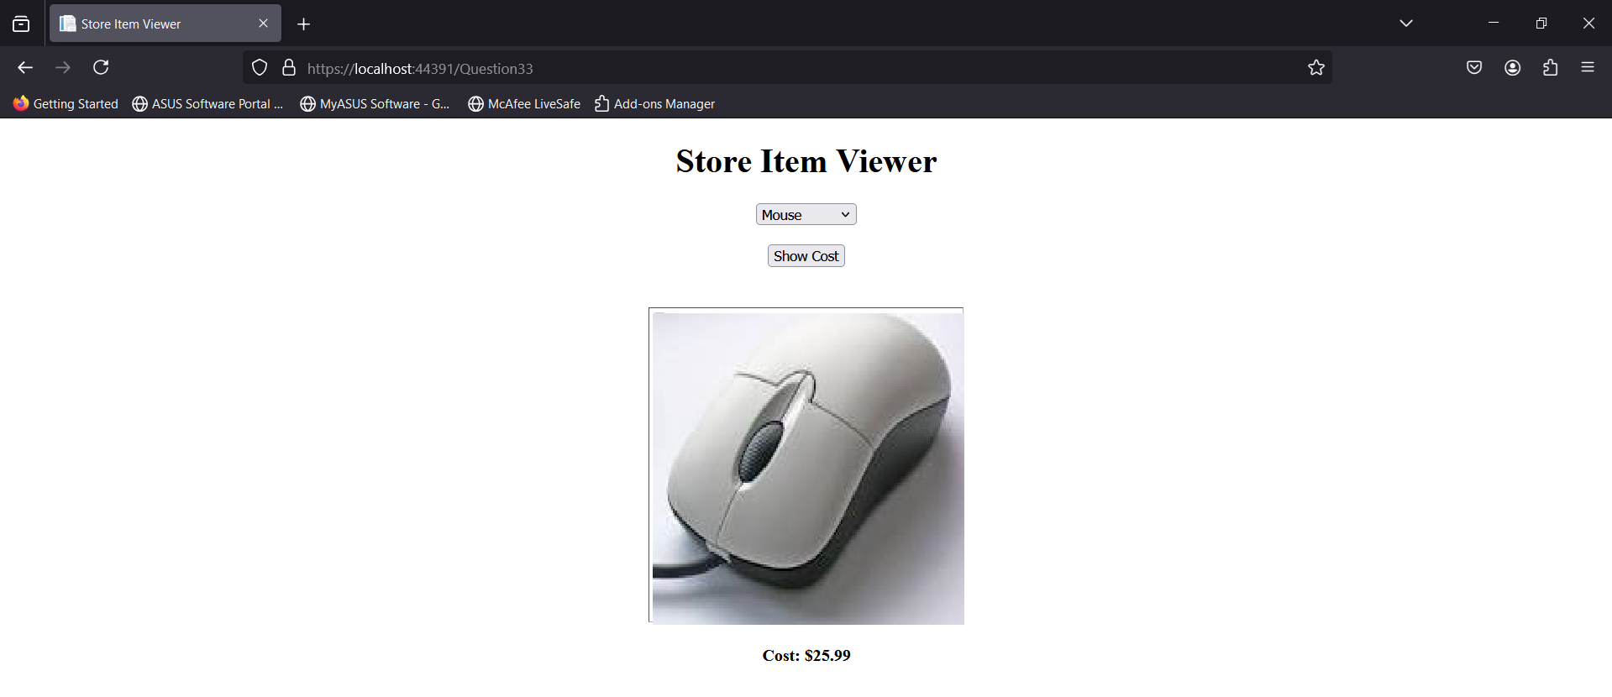

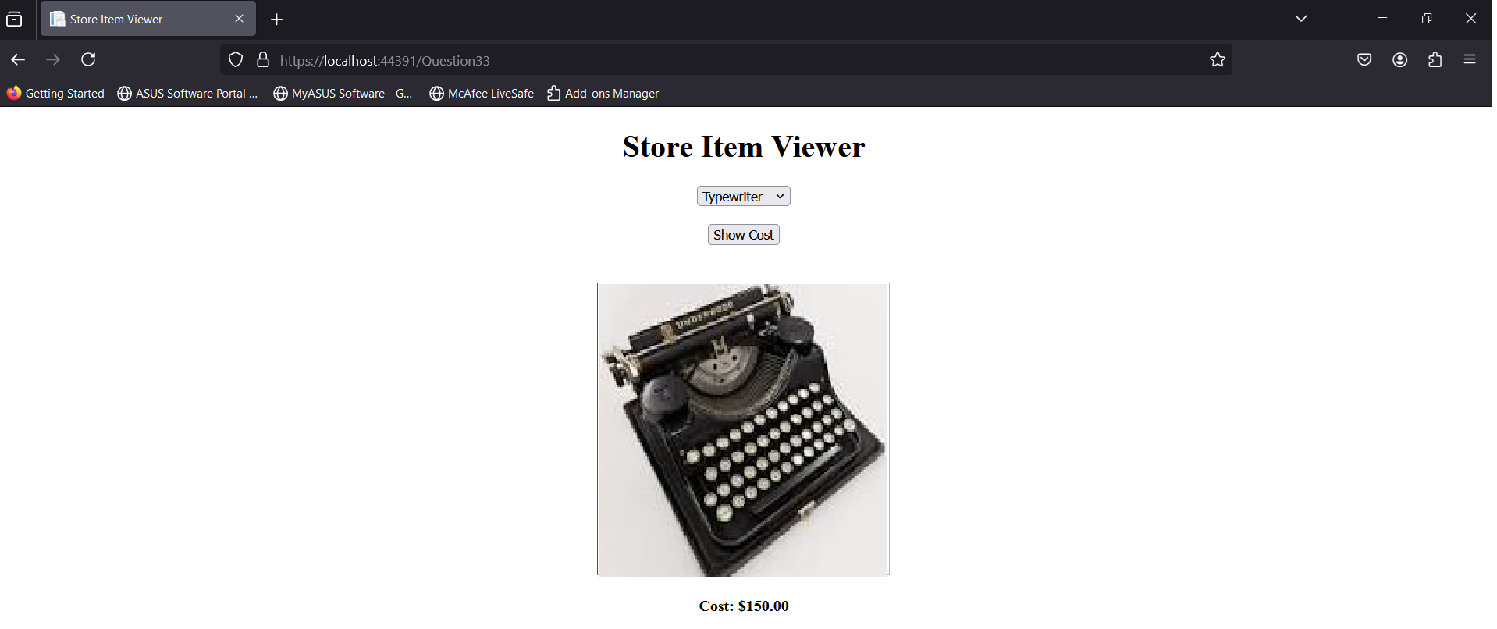

Program No.34
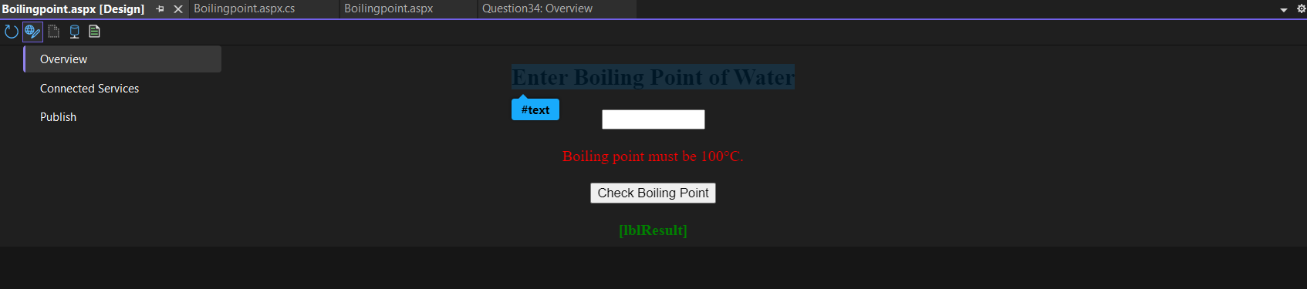
Program: Write a program to get a user input such as the boiling point of water and test it to the appropriate value using Compare Validator.

Code:-
<%@ Page Language="C#" AutoEventWireup="true" CodeBehind="Boilingpoint.aspx.cs" Inherits="Question34.Boilingpoint" %>
<!DOCTYPE html>
<html xmlns="http://www.w3.org/1999/xhtml">
<head runat="server">
<title>Boiling Point Validation</title>
<style>
.container {
width: 300px;
margin: auto;
text-align: center;
}
</style>
</head>
<body>
<form id="form1" runat="server">
<div class="container">
<h2>Enter Boiling Point of Water</h2>
<!-- TextBox for user input -->
<asp:TextBox ID="txtBoilingPoint" runat="server" Width="100px" />
<br /><br />
<!-- CompareValidator to validate the boiling point -->
<asp:CompareValidator
ID="cvBoilingPoint"
runat="server"
ControlToValidate="txtBoilingPoint"
Type="Double"
Operator="Equal"
ValueToCompare="100"
ErrorMessage="Boiling point must be 100°C."
ForeColor="Red" />
<br /><br />
<!-- Button to trigger the validation -->
<asp:Button ID="btnCheck" runat="server" Text="Check Boiling Point" OnClick="btnCheck_Click" />
<br /><br />
<!-- Label to display validation result -->
<asp:Label ID="lblResult" runat="server" Text="" Font-Bold="true" ForeColor="Green" />
</div>
</form>
</body>
</html>
Code Behind Logic:-
using System;
using System.Collections.Generic;
using System.Linq;
using System.Web;
using System.Web.UI;
using System.Web.UI.WebControls;

namespace Question34
{
public partial class Boilingpoint : System.Web.UI.Page
{
protected void Page_Load(object sender, EventArgs e)
{
}
protected void btnCheck_Click(object sender, EventArgs e)
{
// Validate the CompareValidator manually
if (cvBoilingPoint.IsValid)
{
lblResult.Text = "The boiling point is correct: 100°C.";
lblResult.ForeColor = System.Drawing.Color.Green;
}
else
{
lblResult.Text = "The boiling point is incorrect. Please enter 100°C.";
lblResult.ForeColor = System.Drawing.Color.Red;
}
}
}
}

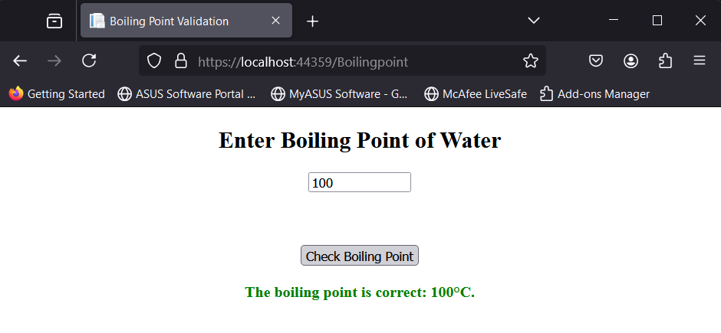
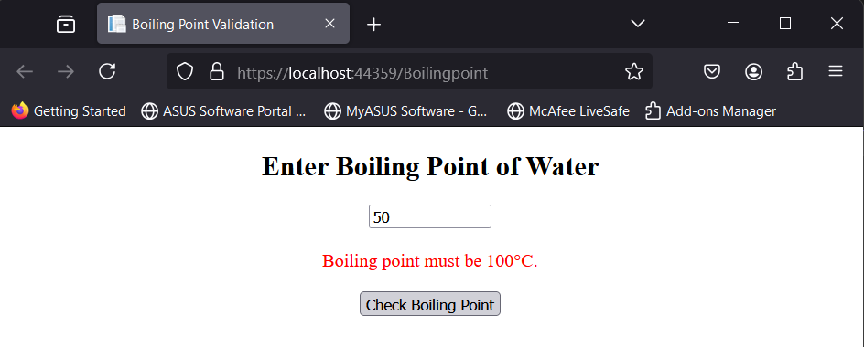
Output:-

Program No.35
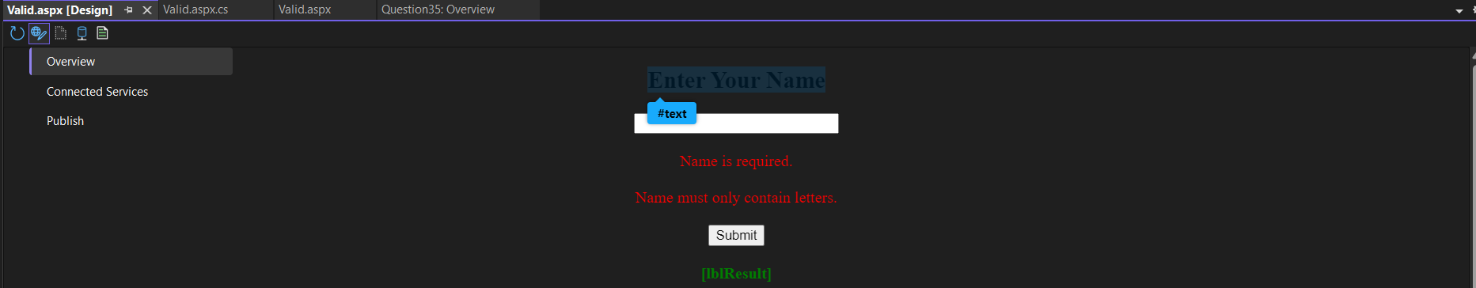
Program: Write a program that uses a textbox for a user input name and validate it for Required Field Validation.

Code:-
<%@ Page Language="C#" AutoEventWireup="true" CodeBehind="Valid.aspx.cs" Inherits="Question35.Valid" %>
<!DOCTYPE html>
<html xmlns="http://www.w3.org/1999/xhtml">
<head runat="server">
<title>Name Validation</title>
<style>
.container {
width: 300px;
margin: auto;
text-align: center;
}
</style>
</head>
<body>
<form id="form1" runat="server">
<div class="container">
<h2>Enter Your Name</h2>
<!-- TextBox for user input -->
<asp:TextBox ID="txtName" runat="server" Width="200px" />
<br /><br />
<!-- RequiredFieldValidator to validate that the name is not empty -->
<asp:RequiredFieldValidator
ID="rfvName"
runat="server"
ControlToValidate="txtName"
InitialValue=""
ErrorMessage="Name is required."
ForeColor="Red" />
<br /><br />
<!-- RegularExpressionValidator to ensure only alphabetic characters are entered -->
<asp:RegularExpressionValidator
ID="revName"
runat="server"
ControlToValidate="txtName"
ValidationExpression="^[a-zA-Z]+$"
ErrorMessage="Name must only contain letters."
ForeColor="Red" />
<br /><br />
<!-- Button to trigger the validation -->
<asp:Button ID="btnSubmit" runat="server" Text="Submit" OnClick="btnSubmit_Click" />
<br /><br />

<!-- Label to display the validation result -->
<asp:Label ID="lblResult" runat="server" Text="" Font-Bold="true" ForeColor="Green" />
</div>
</form>
</body>
</html>
Code Behind Logic:-
using System;
using System.Collections.Generic;
using System.Linq;
using System.Web;
using System.Web.UI;
using System.Web.UI.WebControls;
namespace Question35
{
public partial class Valid : System.Web.UI.Page
{
protected void Page_Load(object sender, EventArgs e)
{

}
protected void btnSubmit_Click(object sender, EventArgs e)
{
// Check if the validation passed
if (rfvName.IsValid && revName.IsValid)
{
// If the name is provided, show a success message
lblResult.Text = "Hello, " + txtName.Text + "!";
lblResult.ForeColor = System.Drawing.Color.Green;
}
else
{
// If the validation fails, the RequiredFieldValidator will show the error message
lblResult.Text = "";
} }}}
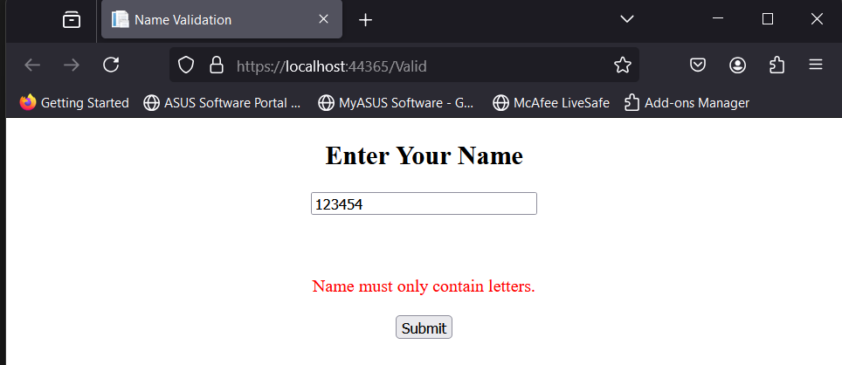
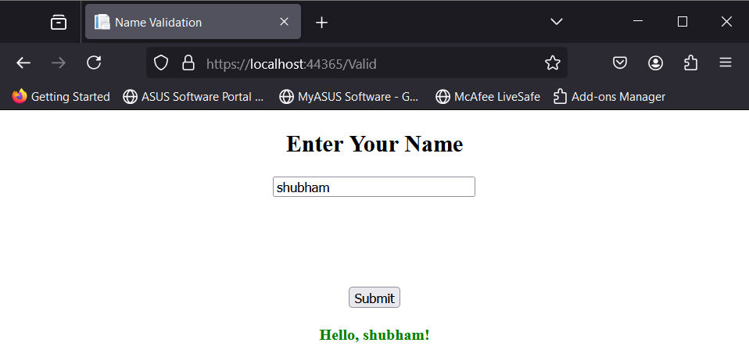
Output:-

Program No.33
Program: Check the length of the string in the TextBox using Custom Validator.
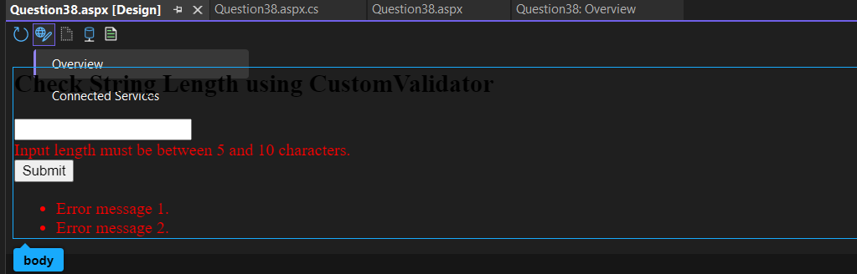
Code:-
<%@ Page Language="C#" AutoEventWireup="true" CodeBehind="Question38.aspx.cs" Inherits="Question38.Question38" %>
<!DOCTYPE html>
<html xmlns="http://www.w3.org/1999/xhtml">
<head runat="server">
<meta charset="utf-8" />
<title>Check String Length</title>
</head>
<body>
<form id="form1" runat="server">
<div>
<h2>Check String Length using CustomValidator</h2>
<asp:TextBox ID="txtInput" runat="server"></asp:TextBox>
<br />
<asp:CustomValidator
ID="cvLength"
runat="server"
ControlToValidate="txtInput"
OnServerValidate="cvLength_ServerValidate"
ErrorMessage="Input length must be between 5 and 10 characters."
ValidationGroup="grpValidation"
ForeColor="Red" />
<br />
<asp:Button ID="btnSubmit" runat="server" Text="Submit" ValidationGroup="grpValidation" OnClick="btnSubmit_Click" />
<asp:ValidationSummary
ID="ValidationSummary1"
runat="server"
ValidationGroup="grpValidation"
ForeColor="Red" />
</div>
</form>
</body>
</html>
Code Behind Logic:-
using System;
using System.Collections.Generic;
using System.Linq;
using System.Web;
using System.Web.UI;
using System.Web.UI.WebControls;
namespace Question38
{
public partial class Question38 : System.Web.UI.Page
{
protected void Page_Load(object sender, EventArgs e)
{
}
protected void cvLength_ServerValidate(object source, System.Web.UI.WebControls.ServerValidateEventArgs args)
{
string inputText = txtInput.Text.Trim();
if (inputText.Length >= 5 && inputText.Length <= 10)
{
args.IsValid = true;
}
else
{
args.IsValid = false;
}
}
protected void btnSubmit_Click(object sender, EventArgs e){
if (Page.IsValid)
{
Response.Write("Form Submitted Successfully!");
}
else
{
Response.Write("Please correct the errors.");
} }}}

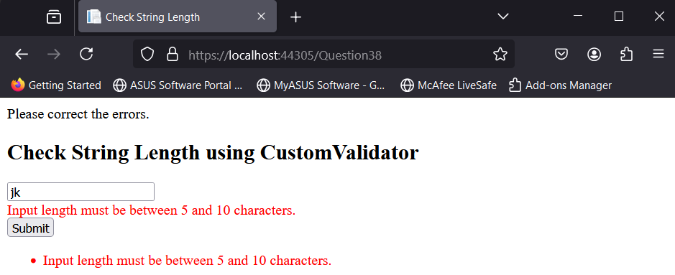
Output:-

